Easter in the Shadows
A Sermon Preached at Lawrence Park Community Church, April 21, 2018
Text: John 12:22-26
Rev. John Suk, PhD

I have always had a very difficult time writing Easter sermons. It happened again, this week. Inspite of hours spent at my desk, studying, making notes, and writing outlines, Thursday morning I still had nothing.

To be honest, the great fire at the Cathedral of Notre Dame was part of the reason. I felt I just had to fit that fire into my Easter sermon, somehow. The promises to rebuild might be a focus. The need not merely for bricks and mortar, but to bless the poor and dispossessed gnawed at me. I wasn’t sure how to proceed.

Anyway, this past week, as I felt time slipping away and Sunday approaching, I asked myself, “Other than the fire at Notre Dame, what’s my problem? Why isn’t this sermon getting done?”

Finally, after a sleepless night on Wednesday and several hours of pacing back and forth in my living room on Thursday, I decided that there are at least two reasons why Easter sermons are always hard for me. The first reason is that Easter Sunday is never quite enough to erase the memory of Good Friday.

The African American poet James Weldon Johnson describes Good Friday this way:

On Calvary, on Calvary,
They crucified my Jesus.
They nailed him to the cruel tree,
And the hammer!
The hammer!
The hammer!
Rang through Jerusalem's streets.
The hammer!
Rang through Jerusalem's streets.

Jeusus, my lamb-like Jesus,
Shivering as the nails go through his hands;
Jesus, my lamb-like Jesus,
Shivering as the nails go through his feet.
Jesus, my darling Jesus,
Groaning as the Roman spear plunged in his side;
. . .
Oh, look how they done my Jesus.

Mary,
Weeping Mary,
Sees her poor little Jesus on the cruel cross.
Mary,
Weeping Mary,
Sees her sweet, baby Jesus on the cruel cross,
Hanging between two thieves.

And so on. It’s a ugly tableau. Good Friday is so sombre, too sad, a horrific snapshot of humans at their worst. And Easter, in spite of spring carnations and chocolate bunnies and the resurrection story we read at the beginning of today’s worship . . . Easter is never enough, by itself, to erase the memory of Good Friday.

But there is a second reason why I have found it hard to write resurrection sermons. You see, the resurrection also turns out to be God's stamp of approval for the way of the cross. It’s like this. “Christ suffered for you,” says the Apostle Peter, “leaving you an example, that you should follow in his steps." That’s hard.

It is like this. I had an Nigerian friend in seminary who put it this way. He showed me a picture in the Good News For Modern Man Bible.

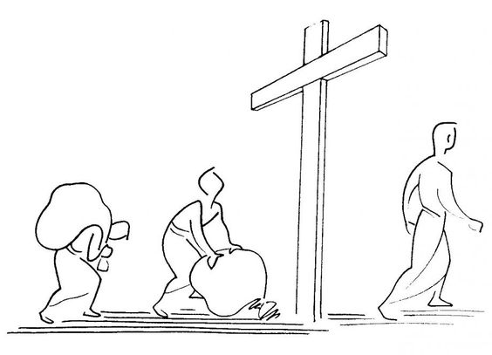

In the picture someone is carrying a huge bag of sin and shame up the steep slope of Golgatha. That person is bent double under the load. The second frame of the picture show the person dumping that load of sin and shame at the foot of the cross. And the third picture shows this person striding away from the cross, back straight, shoulders back, confident, happy and unburdened.

My African friend said, "That picture sums up the trouble with you rich North American students here at the seminary. You think the message of the cross is about how to rid yourself of your burdens and sins and guilt. You think the cross is like a divine get-out-of-jail-free card. But you’re wrong. This picture is all wrong! What the picture should show, really, is this person coming to the foot of the cross not to unburdon himself or herself, but this person should come the cross in order to pick it up, and carry it on his or her shoulders. You see, Jesus said, “take up my cross and follow me.”

"The message of Jesus' death and resurrection" said my friend, "is that somehow God wins by enlisting us to turn the other cheek, by enlisting us to love our enemies, by enlisting us to engage in the sort of political resistance that got Jesus arrested and convicted, by enlisting us to look after the last and least and sick and hungry, and all this is inconvenient and even difficult, but this is what is meant by the words, “take up the cross and follow Jesus.”

You North Americans use the the cross to convince yourselves you are personally and privately made guilt free. Wrong. The crucifixion is our motivation to spend our lives on others, and especially for those who carry heavy burdens.

A sobering thought.

But now, having shared with you why writing Easter sermons written in the shadow of Good Friday and crucifixion can be difficult, I can happily finish this message by telling you about the light side of Easter, too. You see, we are the body of Christ, and so the resurrection means that in Christ Jesus we are the life and light of the world. We get to shine. We are a rich harvest of fruit.

And Jesus’ resurrection—however you exactly imagine it—certainly has borne a great deal of fruit, here, already. We are a garden of delights. And Jesus’ teachings, his political activism, his non-violent resistance, and his kindness to the sick and hungry—Jesus’ friends, Christian or not, who have chosen to carry crosses have worked powerfully against the worst instincts of humanity to make not just this church but our entire world a better place.

Jesus’ resurrection makes us the fruitful harvest of thirty, sixty, a hundred times more than was planted. That harvest means copious kindness here, bountiful insight, abundant encouragment, prolific generosity, ample warmth, prolific hospitality—Jesus resurrection harvest means all such things will flow from Jesus through us to each other and beyond. And I haven’t even mentioned great faith, solid hope, or divine love.

This is our adventure, our life, our chance. This is Easter, exhilerating, even if it still feels in the shadow of Good Friday.

