Her Reputation Preceded Her
A Sermon Preached at Lawrence Park Community Church on June 2, 2019
Luke 7:36-50
Rev. John D. Suk, PhD

She has no name. Tradition, however, suggests she was a prostitute. One day, she scandalizes a troop of carnivorous religious leaders by entering their banquet hall. None will admit to knowing her—though I suspect some did.

The nameless woman shambles over to Jesus. She washes his feet with tears and dries them with her hair. She pours very dear, soothing oil on Jesus' feet and kisses them. For a nameless woman suspected of being a prostitute, this is a very daring, sensual, dramatic act in public, for a prostitute. But Jesus doesn't bat an eye.

Today we welcome a new minister, Stephen Milton. When I chose this passage, I thought the theme would be something like, "ministers need to love parishioners like Jesus loved this woman or like this woman loved Jesus." Maybe I’ll say something like that before the end of this message.

But when I actually started thinking about this sermon I ran into a problem—not the nameless woman but Simon the Pharisee. The banquet is at his house. Like Stephen and I, he is a religious leader. And he is the focus of Jesus’ remarks.

Simon is a model religious leader. He snubs Jesus. He doesn't bathe Jesus' feet or greet him with a kiss, or dab Jesus with a little oil, as custom demanded. Simon probably saw Jesus, for all the crowds that followed him, as too big for his britches. Jesus was merely an unemployed carpenter, for God’s sake. So, the plan was to take him down a notch or two over lamb. Religious leaders have standards, after all.

On the other hand, according to the story, at least, Jesus decided, in turn, to take Simon down a notch or two. In fact, we read in the New Testament that Jesus often condemned religious leaders. The best of the lot, Nicodemus, was a fence sitter and coward. Matthew actually devotes a whole chapter to Jesus' criticism of religious leaders. "Woe to you, scribes and Pharisees, you blind guides! . . . on the outside [you] look righteous to others, but inside you are full of hypocrisy and lawlessness." And so on.

Anyway, even though Simon is the one Jesus addresses in this passage, and even though as the religious leader, Simon is the obvious point of comparison for today’s sermon, Simon is not very inspiring. He is a negative example for what religious leaders should be and he really bugs Jesus.

But, the thing is, Simon has a name and the woman does not. Simon, already a big shot, also tries to make more of a name for himself by putting Jesus down and thus elevating himself. By way of contrast, our positive example here, for religious leadership, the nameless woman is content to minister to Jesus anonymously, without any hope of improving her already miserable standing.

Where Simon tries to make a fool of Jesus, the nameless woman makes a fool of herself by weeping at Jesus’ feet. Where Simon snubs Jesus, the woman demonstrates how the greatest of these is love. Where Simon believes he belongs at the table with his righteous friends, comfortable in his name and reputation, the nameless woman is forgiven all and goes in peace.

In the end, the irony of this story is that the great religious leader Simon is the one who has the most to learn, and it is the nameless prostitute who teaches. She does so by emptying herself of all the faux prestige and power and pride that mark Simon’s leadership, and that tempts all leaders, religious or not, including you, Stephen, and me.

She empties herself. Emptiness doesn't have much status in our culture. But in eastern cultures, emptiness is prized for its positive potential. For example, one of my parishioners in Ann Arbor was a Chinese student. She gave Irene and I this painting her mother made.

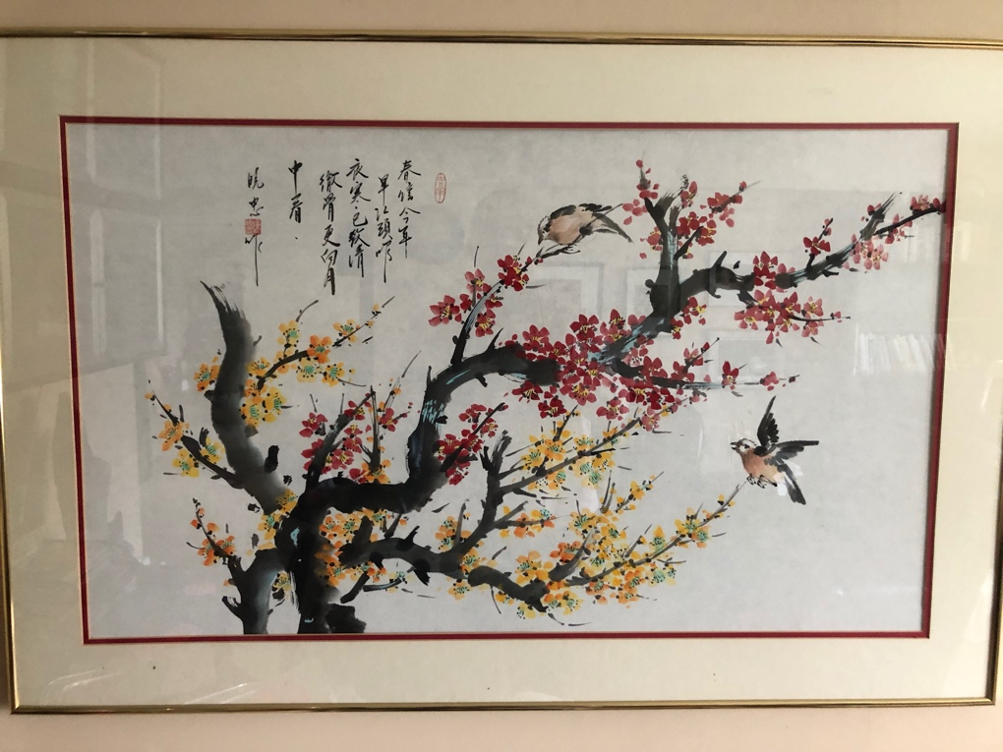

There are a few nightingales in a mulberry tree. But mostly, the painting is empty space. My Chinese friend said that oriental artists usually spend more time on planning the empty space than on filling it. Emptiness gives this art its power.

Or again, in Korea instead of using firs as Christmas trees, Christians often decorate bamboo plants, instead. You see, bamboo is empty inside. This emptiness means that even though bamboo is very light it is also very strong. And so, in the emptiness of bamboo Koreans see a living parable of the mystery of who Jesus is and what he did and what we should strive for. Paul says that we should all have the same mindset as Jesus, who "emptied himself, taking the form of a slave, and humbled himself, and became obedient to the point of death." For Koreans bamboo symbolizes the mystery of Jesus’ sacrifices and for me it symbolizes my striving to be like him.

Simon was full of himself. But the nameless woman came to Simon’s banquet hall empty of pretension and in spite of her bad reputation. She is empty but gives Jesus simple gifts from the bottom of her heart—tears, hair, perfume, shame and a desire for new life. She is empty, and this gives her power.

Today we welcome Stephen as our new religious leader. So far, and like Simon, you do have a name, of course, and an excellent reputation. We won’t count that against you, especially since you not yet begun your work here. But we all hope for the kind and selfless service from you, and from each other, that the nameless woman offered Jesus. A willingness to empty yourself is the key to religious leadership in Jesus’ shadow.

