“Sermon: In Too Deep”

Rev. Stephen Milton
July 14th, 2019

1
This scene in the Jonah story is by far the most famous. A man living inside a great fish for three days and nights, hitching a ride beneath the ocean. It has amazed people for centuries, and is a favourite among the stories we tell in Sunday school. But the kids get a version which is different from the one we just heard.

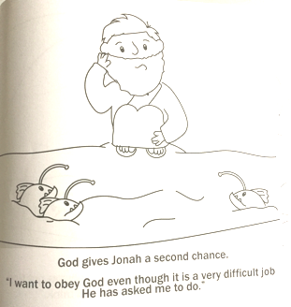
Here is a page from the colouring book John bought for the kids. In it, Jonah gets swallowed by a nice whale. The whale also ingests some lantern fish to light up the belly. Nice. Although it is gooey in there, Jonah decides to help God deliver a message to the Ninevites. You may recall that they are the people who destroyed Northern Israel, earning the hatred of all surviving Israelites. But in the kid version, Jonah lets go of his hatred, and repents inside the whale. The whale is nice, Jonah is nice. God is nice. It’s a great story.

Except that in the real story, which we just heard, Jonah doesn’t repent at all. Instead, he breaks out into song. The words he speaks are a psalm. There are 150 psalms in the Bible. Each one is a song about someone’s relationship to God, often a dialogue with God. Some celebrate God’s love, others thank God. Many are laments, where someone is deeply depressed, and they call on God for help. In those psalms, one of the metaphors for despair is to be drowning, or to be deep underwater. Now, the Israelites were a desert people. These psalms were written over two thousand years ago, long before anyone had invented scuba diving. So, when Israelites sing about being at the bottom of the sea, they mean it as a metaphor for despair. They never mean it literally.

But Jonah goes there. When he finds himself deep below the waves, his first thought is to sing a song about being deep in the ocean, even if it means completely missing the point. It’s always dangerous to explain a joke, so let’s see what this would be like in modern terms. Lately, a number of people in the congregation have had been diagnosed with heart ailments. Let’s imagine what would happen if Jonah had an appointment with a cardiac surgeon. To show you what this would be like I have asked Michele to play the part of Jonah. Cari will be helping us out, too.

( Michele and Stephen sit in facing chairs)

Doctor: Jonah, I’m afraid I have some bad news. One of the arteries of your heart is congested. Next week, we need to get you to surgery so we can fix your heart. Do you understand?

Jonah: ( Stands and sings from “Heartbreak Hotel:
Well, since my baby left me/Well, I found a new place to dwell
Well, it's down at the end of Lonely Street/At Heartbreak Hotel
Where I'll be--where I get so lonely, baby/ Well, I'm so lonely
I get so lonely, I could die) Sits down.

Doctor: Jonah, I don’t think you are getting this. Your heart problems have nothing to do with your love life. You have blockages because you have been smoking three packs of cigarettes a day and your favourite breakfast is bacon with potato chips. I need to get in there and operate or you may die. Do you understand?

Jonah: (Sings from the BeeGees song, “How Can You Mend a Broken Heart?”
And how can you mend this broken man?
How can a loser ever win?
Please help me mend my broken heart
And let me live again…).

You see the problem. Jonah is an egotist, who happily warps reality rather than facing the truth that he is to blame for his situation. If one of us found ourselves in the stinking, gooey belly of a whale, we would probably start bargaining with God. I messed up, I get it now, I should have done what you said at the start. But now, please don’t kill me. I’m sorry, I’ll do whatever you want. In short, we would be like the Jonah in the kid story, seeing the error of our ways.

But in the Bible, Jonah doesn’t feel guilty or panicked. Instead, he is such an egotist that he assumes that God has come to rescue him. After directly disobeying God, he has the gall to think that God has sent the fish to save his life, as though he was a loyal follower of God. If mistakes were made, they were not made by Jonah. Instead, he praises God for saving him, breaking out into song, completely missing the point of the song he is singing, and the situation he is in. Far from being a nice guy, Jonah is first class egotist, who will warp reality to fit his own self-centred view of life. God comes to his recuse because that is what God is for - what else does God have to do with God’s time?

2

The urge to imagine that we are the centre of the world is a strong one. Each of us is born with an ego. It is sort of life our personal gyroscope. It tells us where we are in relation to everything around us. Our ego urges us to cry as babies when we need attention or food. Our ego tells us to stand up for ourselves as we compete for position in school or in the workplace. We need our egos, they are what make sure we get fed and housed. If we don’t care about what happens to us, we cannot always count on anyone else to do so. Egos are good to have.

But our egos, like Jonah’s, can get carried away. Psychologists have found that all of us capable of very strange behaviour due to our ego’s desire to keep face. When we make mistakes, we often come up with silly rationalizations to justify our behaviour. I didn’t rake the leaves because they are good fertilizer for the lawn. I didn’t fill the tank because gas is cheaper on the weekends. We all come up with rationalizations for our behaviour, especially when we make a mistake. Psychologists have found that the bigger the mistake, the more we’ll come up with an alibi for it.
One of the most impressive examples of this was during the George W. Bush administration. Bush told America that Iraq had to be invaded because Saddam Hussein had weapons of mass destruction. But when American invasion troops couldn’t find any, half of all Republicans refused to believe it. They didn’t want to admit they were wrong to believe in Bush, since it went against their belief in their patriotism. So they came up with other reasons for the invasion - Saddam had helped Al Queda during 9/11. This wasn’t true, but when we are protecting our egos, truth is often the first casualty.

The problem is that we don’t want to contradict our sense of self. Most of us want to believe that we are rational people. But when we do something stupid, or forget to do something, rather than admit our mistake, we make up an alibi. I meant to leave the heater on all night, so it would be nice and warm this morning. These alibis allow our egos to appear like they have been in control the entire time, instead of screwing up. Jonah would rather than God while he is the disgusting belly of a whale than admit to his mistake.

Many of these rationalizations can be harmless, but others can be devastating. The #MeToo movement has shown us that powerful men can lie to others and to themselves about their relationships with women. In the film industry we have been shocked to hear about studio executives who have been convinced that their forced advances have been consensual. Men who are convinced that the world loves them are oblivious to the suffering of women who are literally in their arms, staring them in the face. These men would rather believe that they are irresistible than face the truth that they have been engaging in sexual assault for years. Egos can make liars of us all.

3
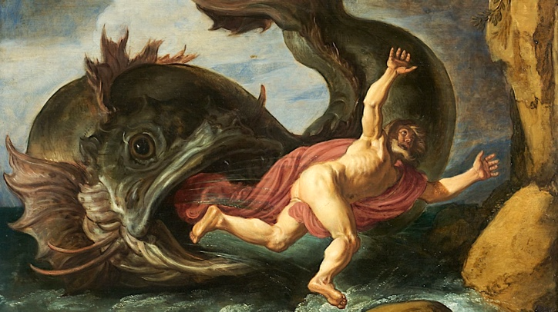

So, what can we do to fight back against this urge for self-delusion? Today’s episode of Jonah provides one strategy: humour. Surrounded by whale guts, Jonah has the gall to make a pious prayer to God. But watch what happens next - God does not reward him by taking him back to Jerusalem. Instead, the story simply says, the great fish barfed Jonah onto the shore. It is the equivalent of a minister finishing a holier than thou sermon, then tripping on a banana peel. Just when Jonah has convinced himself he deserves a seat next to God in heaven, the whale barfs Jonah onto the shore.

The story uses humour to help us see through Jonah’s self-delusion. Jokes work because they demand a sudden change in perspective. We get a chance to see a situation from a radically different angle.

A wife came to a shrink and said, “Doctor, doctor, My husband thinks he is a refrigerator.”
The psychiatrist tells her, “ I wouldn’t worry, as long as he isn’t violent.”
“It’s not that, “ she said,” it’s just that when he sleeps with his mouth open, the little light keeps me awake.”

Two snowmen are standing in a field. One turns to the other and says, “do you smell carrots?”

Here’a an old Jewish joke:
A poor man walking in the forest feels close enough to God to ask, “God, what is a million years to you?”
God replies, “My son, a million years to you is like a second to me.”
The man asks, “God, what is a million dollars to you?”
God replies, “My son, a million dollars to you is less than a penny to me. It means almost nothing to me.”
The man asks, “So God, can I have a million dollars?”
And God replies, “Sure, in a second.”

4
Humour is how we re-orient ourselves, and get away from just the ego’s perspective. People who can’t take a joke are often the ones who are unable to see anyone else’s point of view. President Trump doesn’t laugh, or make real jokes. He is the first president in ages to refuse to attend the annual White House Press Corps dinner, where the President is often roasted. Obama went, and was able to give as good as he got. But Trump doesn’t care about anyone else’s perspective. In fact, this week, he lost a case in court where he had tried to cut off his critics from following him on Twitter. He wants to live in his own bubble, and no other perspectives are allowed in.

Trump shares this single-minded perspective with much of the alt-right. The most worrisome are the neo-Nazis, who, much to our shock, have come back into the spotlight. They, too, have a single m ended view of reality which dismisses and threatens the existence of others.

In North America, our response to neo-Nazis and white supremacists has been to denounce them, and to stage counter protests at their marches. But we are new at this. In Germany and the rest of Europe, neo-Nazis have been marching for longer, so tactics have evolved past counter-marches. In many towns and cities, protesters have taken a page from the Jonah story. Instead of shouting at the neo-Nazis, they have been using humour to fight back.

In this town in Germany, anti-Nazis painted a starting line and a finishing line on the road where the neo-Nazis would be marching. They also put up signs along the road, and cheered the Nazis on as they marched. The signs explained that for every Nazi who completed the march, $12.50 would be donated to a program that helps people escape neo-Nazi gangs, and get back to normal life. So, the town cheered the Nazis on, since the more people who completed the march, the more money they would raise to undermine the Neo-Nazi cause.

In Europe, and now the US, Nazis have been confronted with people dressed as clowns who have marched alongside them. These clowns deliberately make fun of Nazi slogans. When white supremacists chant “White Power”, the clowns reply “White flour” and toss it into the air. When the Nazis counter, no we meant “white Power”, the clowns reply, oh, you mean “Wife Power!”

The towns which have tried this have found that the neo-Nazis are demoralized. For a member of the alt-right, the prospect of getting into a fight at a march is thrilling. But coming home with flour all over you, thrown by a bunch of clowns is a total buzzkill. Just as Jonah’s pomposity was lampooned by the whale’s barfing him onto shore, single-minded extremism can be deflated by humour, too.

But we have to be careful that we don’t just end up single-minded in our response. Humour is not about having the right opinion, but about being able to hold two very different ideas in mind at once. The set up and the punchline co-exist. God in this story is encouraging us to dare to be more open minded than Jonah. He has to go visit people he hates; God expects the same from us. Sociologists in the United States have found that most people who join extremist gangs are not racists or homophobes going in. That comes later, as they get drawn into the group think. No, what unites these recruits is that they are frequently lonely, feeling that they have no friends or community. That’s what makes them vulnerable to recruitment, as ISIS and the alt-right alike have discovered.

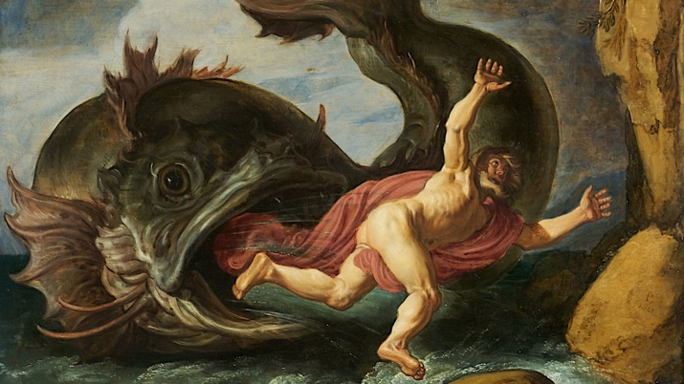

God sends Jonah not to destroy the hated Ninevites, but to talk to them. Two radically different perspectives which God wants to be brought together. They will meet in our next installment of the Jonah story, two weeks from now. But for now, what we can be sure of is that God wants his human children to talk to each other, to share perspectives, to be capable of having more than one point of view. So, let’s keep our sense of humour, especially when things get dark. Being able to laugh is a sign of hope, that we may understand God’s loving vision for us after all…..

Amen

See for example Pslam 88, Psalm 42,Pslam 69.
Steven L Mackenzie, How to Read the Bible, (Oxford University Press, 2005), 8.
Carol Travis and Elliot Aronson, Mistakes were Made( but not by me), ( Harcourt: Toronto,2007), 15.
Carol Travis and Elliot Aronson, Mistakes were Made( but not by me), ( Harcourt: Toronto,2007), 18.
“The Latest: Twitter Ruling Disappoints Justice Department,” New York Times, July 9, 2019.
https://www.washingtonpost.com/news/worldviews/wp/2014/11/17/watch-german-town-plays-prank-on-neo-nazis/?utm_term=.ef4919c621f8
https://wagingnonviolence.org/2017/08/nazis-afraid-clowns/
https://www.nytimes.com/2017/08/17/opinion/how-to-make-fun-of-nazis.html

