“Jonah Part 3: When Doom Comes to Town”

Rev. Stephen Milton
July 27, 2019
Lawrence Park Community Church

In today’s scripture reading, we hear that Jonah is going to Nineveh, which is so big it takes three days to walk across it. But how far is that? Today, we measure distances in terms of driving – Montreal is six hours away by car. But what is a three-day walk?

Well, lately, I have been finding out. As some of you may know, in August my wife, Amanda, and I are going to Portugal. We’re going there to walk the Camino, which is an ancient pilgrimage route which terminates in the Spanish city of Santiago. So, to get ready for this, I have been training. A day’s walk on the Camino is usually 25 kilometers, which takes about five hours, not counting breaks.

How far is that? Well, I have walked from here down to Yonge and College, and that takes 2 hours. To walk from here to my home neighbourhood near High Park would take 2.5 hours. A five-hour, 25 kilometer walk from here gets you all the way to the other side of Pearson International Airport. That’s one day’s walk.
In today’s passage from Jonah, we are told that the city of Ninenveh is three days walk across. That would be like walking from here, all the way to Hamilton (73.7 kms), but as one continuous city. Now, that’s a hard thing to do even in our time, but it was flat out impossible in Biblical times. So, when people heard this part of the Jonah story, they knew it was a crazy exaggeration, like claiming that you’d been to a city with skyscrapers 3 miles high.

But the size of Nineveh isn’t the biggest exaggeration in this story. When Jonah walks for a day into the city, he says one sentence, “Forty more days and Nineveh will be overthrown.” and then suddenly, everyone within hearing distance stops whatever they are doing, and they start to repent.

Workers, housewives, students, cart drivers, everyone realizes that their dangerous city has to change its way. Like dominoes across the city people start repenting, until even the emperor hears of it and joins in.

That would be like a stranger walking into the middle of London, England, setting up a mic, and saying, “Brexit will destroy Britain, stop before it’s too late.” Then walking away, and everyone, from the cabbies to even Boris Johnson changing their ways – that day.

Well, of course, we know that life doesn’t work like that. No one hears just a simple sentence and changes their entire life on the spot. An individual might, but never an entire city. The Hebrews knew this better than anyone. The latter part of the Old Testament contains 16 prophetic books, where God chooses a prophet, and he delivers a message of warning to the people. In the vast majority of cases, the people ignore the prophet’s message. So, this story is like when a parent says, “What’s the matter with you? You never do any chores. Why can’t you be more like your sister? When I say “Honey, can you clean your b – “I don’t even get to say ‘bedroom’, and she gets straight to it, and she cleans the bathroom, too. Why can’t you be more like her?” To the Jews who heard this story, it sounded like a farce. A Jew walks into a pagan town, says one sentence, and they all change their ways instantly, something we Jews never do. And of course, it is impossible, it’s a joke, there’s no way a pagan town is going to change its ways that fast. And just to make sure we get the joke, the emperor gives an order for the animals to repent, too.

Facts or Dreams The story clearly recognizes that when you need to convince people to change their ways, a simple statement of fact or warning is not going to do it. Lately, we have been learning this the hard way.

This week, Robert Mueller gave testimony for an entire day to Congress, reiterating the findings of his 488 page report. 488 pages that clearly establish that the president and his staff obstructed justice, over and over again. Yet, still the Democrats are unwilling to impeach him. In Britain, Boris Johnson is the new Prime Minister, even though it is not clear that he lies about Brexit during its first campaign, and Europe has already rejected his proposed deal to fix it.

We seem to be surrounded by political situations where reason doesn’t seem to make any difference at all. Even facts seem irrelevant now. But, if facts and the truth don’t matter, what does matter to convince people to act?

Trump and Boris Johnson know. Facts don’t matter, dreams and visions do. No fact can defeat a well told lie that appeals to what people want to believe. Make America Great Again – it doesn’t matter that America in the 1950s was paranoid and scared about nuclear war. It doesn’t matter that in the 1950s America was a hard place for people of colour and for women of all races, who weren’t allowed to work. Trump isn’t selling reality, he is selling a racist’s dream of America in its heyday. Boris Johnson is selling a dream of an independent Britain, the echo of its time as a mighty empire. These dreams are powerful, and can override rational analyses and facts, and even 488-page long reports. As well-meaning as it may be, appealing to reason as the way people vote is naïve.

Dream Big
If reason isn’t enough to convince people, what can we do? Jonah’s story suggests the solution: dream big. When the Jonah story first appeared, it was read as a farce, a satire on prophecy. But dreams have a way of floating through time, changing and amplifying as they go. The Jonah story didn’t disappear, but it morphed into something wonderful.

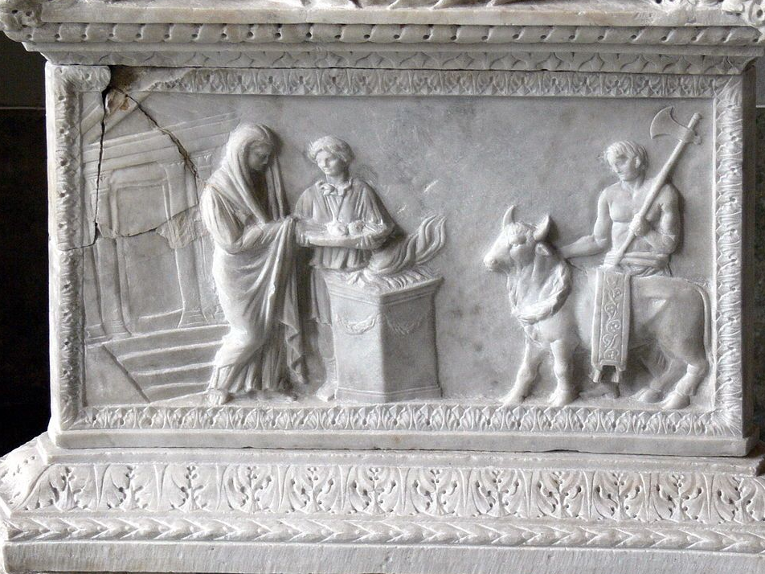
The Ninvevites’ great empire didn’t last long. It was destroyed by the Babylonians, and then they fell, too, until eventually, the Romans were in charge. They set up what today we would call an evil empire. In the year 100, about one third of all the people living in Rome were slaves. Slaves lived in constant fear of violence and death. Their masters could beat them or kill them anytime they wanted, it was perfectly legal. Think of that – one third of your city living in fear, enslaved. Fear and violence were everywhere – when people got a day off from work, they would go to the games, in big arenas. Here, part of the entertainment was to watch people being killed by lions and gladiators. Life snuff films, but live. That was a nice afternoon out.

And people didn’t just fear each other – the gods were scary, too. Every city was filled with altars and temples to the gods. There were altars at every city gate, in homes, on streets, in the temples. The reason was that it was believed that unless you paid the gods in animal sacrifices, they would remove their favour from your family, or your city. Unhappy gods would then send famines, plagues, allow military defeats. The Romans lived in a cosmic protection racket. Fear and the threat of violence was everywhere.

It was in this setting that the message of Christianity first took root. In the year 100, people started hearing about a God who had paid the ultimate house call – not to punish people, but to help them. A god who lived and died as a human being, to teach love and compassion. That was a crazy idea. It attracted slaves and women first, because they were the ones who suffered most in Roman society. Here was a God who cared about human beings, and taught that the answer to life was being loving and compassionate to all, even your enemies. It sounded like a dream, impossible, but people slowly started to choose to try it out.

But, there was a problem. The Romans needed everyone to make sacrifices to their gods so that the gods wouldn’t withdraw their favour from the empire. But the new Christians were taught that the other gods were simply delusions, non-existent. So, they refused to make sacrifices. For this, the Romans called them atheists. The first Christians were known as atheists. And the punishment for atheism was to be thrown to the lions in the arenas.

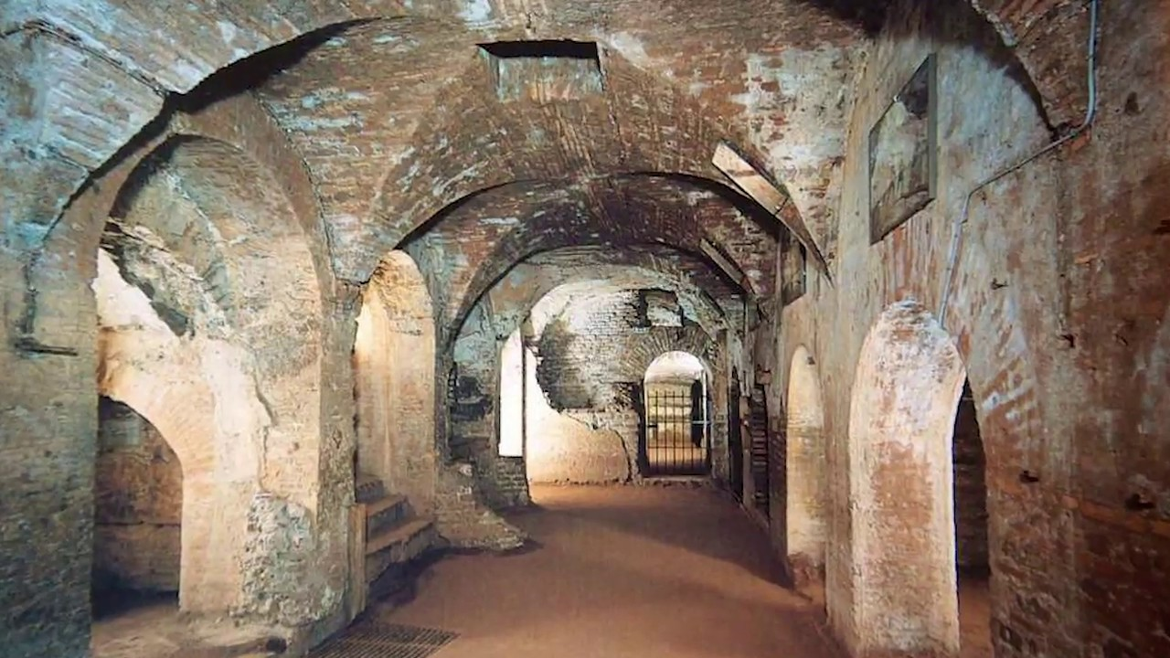
Since Christianity was illegal, it spread slowly. Mostly by word of mouth. One friend told another, someone he or she could trust. They met in secret, in houses. And that secrecy lasted even when they died.

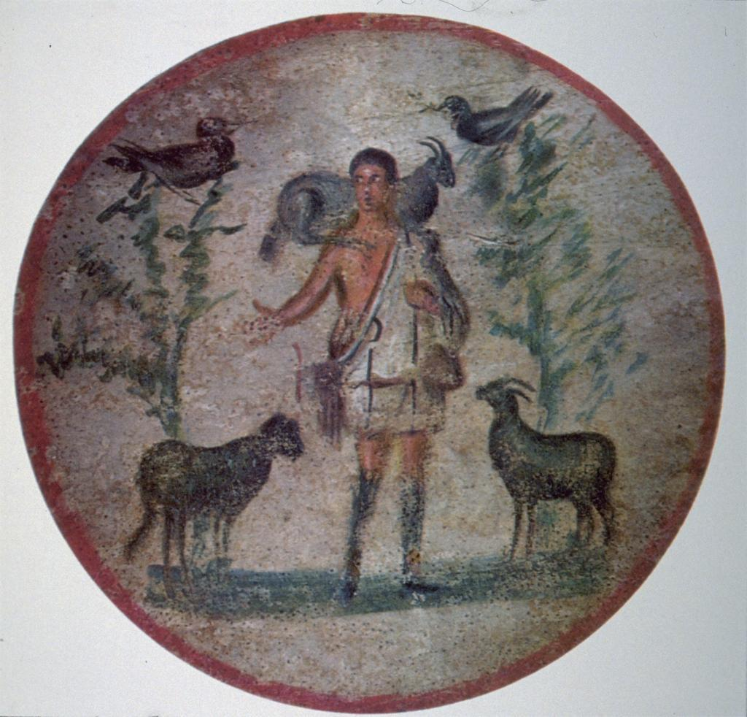
Like other Romans, they buried their dead in underground tombs, known as catacombs. This is what they looked like. Romans liked to paint the walls of their tombs, with images of their gods, and pictures of nature. So, when the Christians buried their dead, they painted the walls, too. But they chose to put up symbols of their faith that would not be obviously Christian to any pagans walking by.

Good Shepherd When they wanted to represent Christ, they painted the good shepherd, rescuing his sheep. This was the most common way to show Jesus in the 200s when these images first appear. It would be many, many centuries before Christ on the cross became a common symbol. Christ as a kindly shepherd rescuing the souls of the dead was how he started out in images.

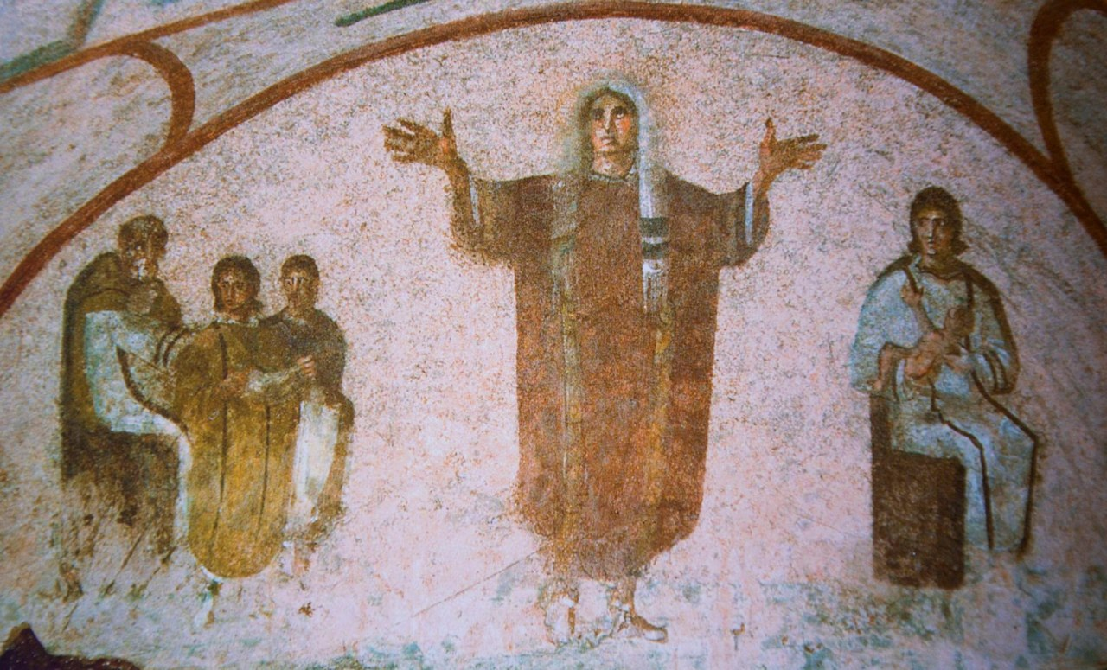
They also painted images of the life of the deceased. This woman is shown praying in the afterlife, with her hands lifted into a W shape, which was the way all Christians prayed back then. Ministers today still use this shape when we do the benediction at the end of the service.

Jonah Returns
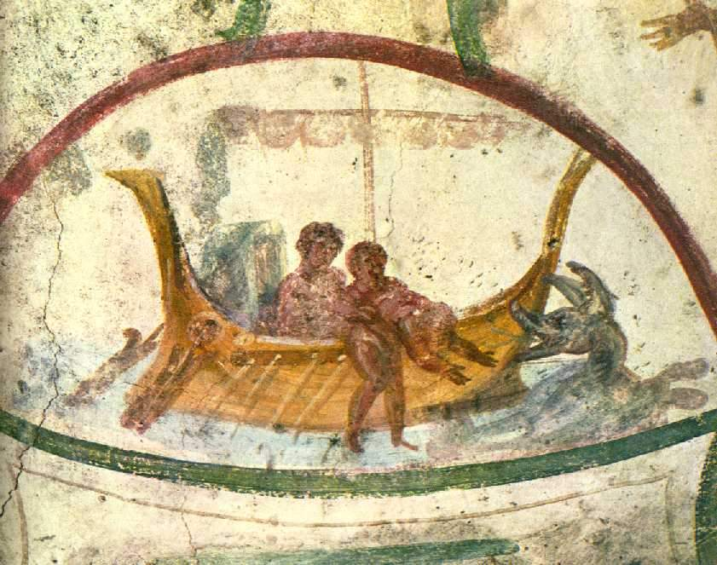

But of all the images found in these first Christian tombs, these are the ones that are the most frequent. Do you see what it shows? A man being thrown off a boat, into the sea. It’s Jonah. Instead of a whale, he is going to be swallowed by a sea monster.

Thrown up. And here he is being thrown up onto the shore.

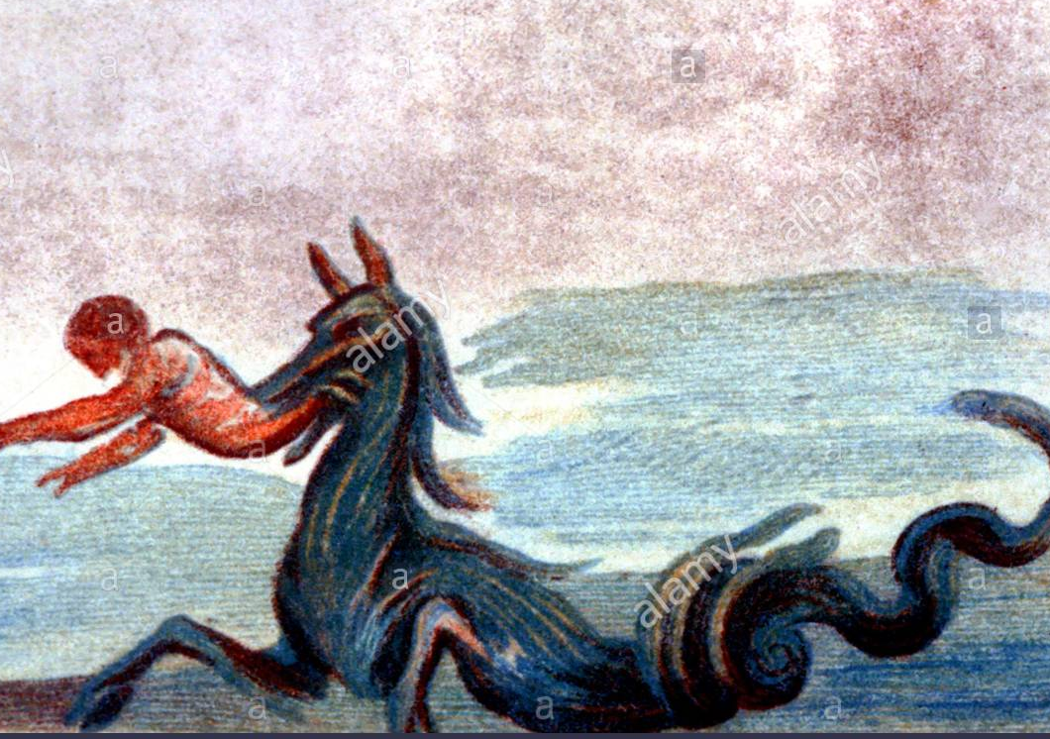
Under Bower. And here he is in Nineveh, relaxing after he has delivered his prophecy.

This strange tale really resonated with the first Christians, for a few reasons. First, Jonah is in the belly of the fish for three days, just as Christ is dead for three days. So Jonah’s story became symbolic of the bodily resurrection of Jesus. This wasn’t what the Jews had in mind when they heard it, but stories don’t have fixed meanings, so this one morphed. Death, was depicted as a scary sea monster, not a friendly fish, but one that was not stronger than God’s love. So, Jonah became symbolic of the hope that there is life after death.

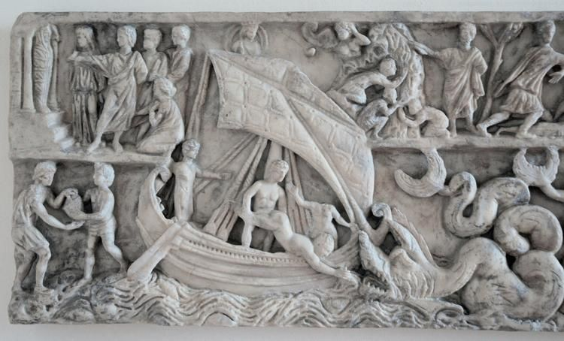
The other reason Christians loved this story was that Jonah came to save the pagans of Nineveh. Most of the people who converted to Christianity were not Jews, but Romans and Greeks. So, when they looked into the Bible for stories about God saving non-Jews, they loved the Jonah story. They could be members of the evil Roman empire, and still be offered the chance to enter God’s love, and to follow Jesus. If the Ninevites could be saved, so could any Roman or Greek.

So, this strange, satirical story of a lousy prophet got a makeover by the early Christians. The idea that an entire pagan city could be saved became a dream worth dreaming. It became an inspiration. And the bizarre thing is, it came true. Not in a day, like in the Jonah story. It took time. Word slowly spread, person to person, about the word of God, that love was the answer. And in 337, almost exactly 300 years after Christ died, the emperor Constantine, was baptized a Christian. He made Christianity into a legal religion, and within a few decades, it would become the official religion of the Roman empire. Jonah’s story had come true, not in a day, but it came true. The pagan empire listened to the word of God.

Dreams are powerful. They can sound absolutely impossible, but they have the power to inspire new realities. The crazier they sound, the bigger the distance between their vision and our reality. The Bible is a book of dreams. Visions of a reality where love wins, where compassion is the law, where death is not final. When we are locked in lives of narrow personal gain and collective violence, its message will sound the most nonsensical. It can be easily dismissed as childish or impractical. But make no mistake – human beings are far more influenced by dreams that we are by reason. Our worst and best politicians know this to be so.

The question is not whether we should dream, but what kind of dreams we need to embrace and foster. In this age of reason, our churches need to be the cradle of dreams of a better future. We need to entertain visions of what the world would be like if we did change our ways. What does Toronto look like when it kicks its carbon habit? Are there gardens on every apartment roof? Do Sunnybrook and Glendon and U of T and Queen’s Park switch to geothermal heating, the kind that keeps this church cool in the summer and warm in the winter? Does Bayview Avenue get taken over by bikes and clean transit? What does a city look like with true racial equity and enough housing for all?

This church is standing here today because long ago, those early Christians believed that love was what God wants us to live by. They risked their lives to spread that message. Now, we have inherited God’s dreams: where messengers are sent to unlikely, big, scary places with a message that sounds crazy. But that’s what we are called to do. Dream big, dream of a world that works for everybody, not just the winners and the alphas. Let’s carry on that tradition, with initiatives like Soul Table, where we can do that dreaming by inviting in visionaries to talk about how to make this world a better place. Let’s carry on that tradition here on Sunday mornings, where we steep ourselves in these sacred dreamy stories that still have the power to change the world. Let us be Jonah – Nineveh is waiting. We may feel nervous, unqualified, just like Jonah. But we needn’t worry – God is the power behind this plan. We just have to show up and let the dreaming begin.

Amen.

Sandra R Joshel, Slavery in the Roman World: 1/3 enslaved: p.56; could be executed or beaten by masters: p.40-1.
Lauren Beversluis, "The Contemporary Question of Images and Early Christian Art," Church Life Journal, October 10, 2018. https://churchlifejournal.nd.edu/articles/the-contemporary-question-of-images-and-early-christian-art/

