“Jonah 4: Why save Them?”
Rev. Stephen Milton
August 4, 2019

Here we are – at the finish line with the Jonah story. The first three chapters of the Jonah story are epic in scale. The stakes are sky high – the capitol city of a powerful empire is going to destroyed by God. There’s a huge storm at sea that will kill everyone on board Jonah’s boat. A huge fish swallows Jonah. Then there’s the epic scale of Nineveh – a three day walk across the biggest city the world had ever seen at that time. Everything about the story has been huge and epic in scale. But this week, the focus of the story shifts dramatically. The city has repented, and God has decided not to destroy Nineveh after all. And now, instead of the fate of a city, the story narrows down to the scale of just one man, sitting under a tree.

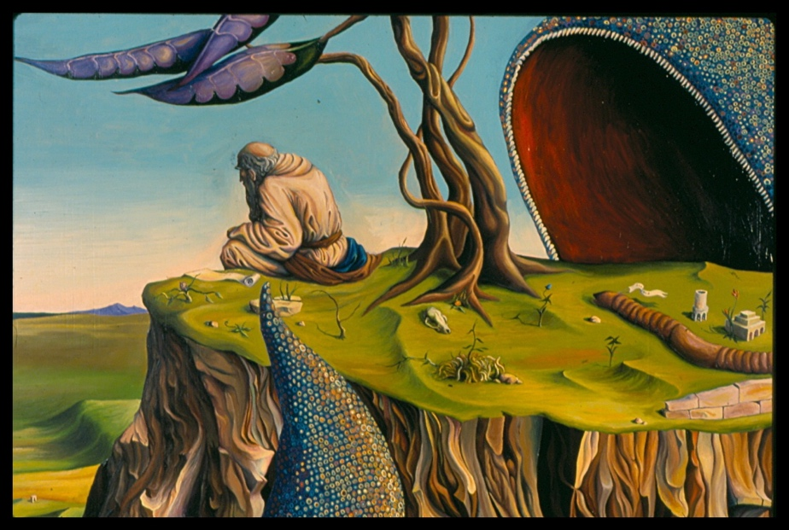

And that one man under the tree is not happy. Jonah is angry. He tells us that three times. He’s angry because he wanted God to destroy the Ninevites. He hates them for invading Northern Israel. He wanted them to be destroyed by God. But, God has relented, and now Jonah is stewing in his anger.

Anger is a powerful and difficult emotion. It appears in animals, so we know that it is something we have inherited in our evolution. Anger persists in us because it can be very useful. If you are under attack, you need to be able to act quickly, and sometimes, you need great strength and speed to defend yourself. Anger sparks a whole host of physiological responses – it can trigger a burst of adrenaline so you can be faster if you need to run, or stronger if you need to use force. When we get angry, our heart rate increases, cortisol levels drop, and we can forget about hunger for a while. Anger is not an idea but an emotional experience, that affects us physically and mentally.

One of the primary effects of anger is that it allows us to focus in on what is threatening us. I was camping once with the kids. It was dark, so we were going to roast some marshmallows. But they wanted to go to the bathroom first, so I took them to the nearest outhouse. But when we got back, we found that there was a raccoon on the picnic table, eating the marshmallows we had left there. Without thinking I started to yell in anger at the raccoon, and I ran towards him. Fortunately, he wasn’t a city raccoon, so he took the hint, and left. I didn’t think about doing any of those things, I just did them, immediately. My body and mind knew what to do, pretty much instantly.

It makes sense that anger is tuned to dealing with threatening animals, in our past there were many predators – but there are also modern kinds of anger, too. There’s computer rage, when you need your computer to do something, or print something, and it just won’t, and you have no idea why.

There’s also the kind of anger we experience when we are driving. Imagine that you are in your car, waiting to make a left-hand turn. Suddenly, as the light goes yellow, another car on your right cuts in front of you, and makes the left. The light turns red, and you’re stuck in the middle of the intersection. How do you react? Angry, right? You yell at them, honk your horn.

This is an example of road rage, a modern version of anger. In some cases, if you really get mad, you may decide to chase after that car, even bump into it to express your anger. People get like this all the time – 1/3 of people report having experienced road rage. Even race car drivers get road rage, and they are used to being cut off. Scholars have suggested that the reason people get so mad in their cars is that deep down we feel like our cars are our territory, so we want to protect it. Most cars are like living rooms on wheels, they are an extension of ourselves. When someone cuts us off or bumps into us, they are threatening our sense of safety and integrity. So, we react with anger.

Now, if you choose to chase that car, there’s a pretty good chance that the passengers in your car will tell you to calm down, to let it go. They don’t feel the insult as keenly as you do, and they can see that this situation is now getting dangerous. But when we get angry, one of the things that happens is that our focus gets very narrow. We forget about everything else around us, and we ascribe our crisis to this one cause.

Scientists have found that this narrowing of attention happens because when we get angry, it’s the left side of our brain that takes over. It’s the side of the brain that deals with details, and manipulating the world. It is in control of our right hand, which is why that’s the hand that gets used for tools and writing. There’s nothing special about the hand, it is the part of the brain that controls it which is very good at detail work. So, when we get angry, it’s the part of our brain that focuses on a few details which is in charge.

That’s why if we’re camping and we see a raccoon, all that matters is that raccoon – the birds chirping in the trees don’t matter, the sound of laughter from other camp sites – we don’t even notice. Our focus becomes very narrow, as we train all of our attention on what threatens us, the object of our anger. Same thing in the car – suddenly all we care about is that other car. We ignore what’s on the radio, and we often ignore at what anyone else in the car is saying, or we tell them to be quiet. That’s the price of anger: it focuses on the threat, and ignores everything else.

That narrowing of focus is very useful during an attack, since you don’t want to be distracted, but what about afterwards? What if your anger lingers even after the event is over? That’s what has happened to Jonah. He starts off angry at God, and the Ninevites. He’s angry that he didn’t get his way, which was to see the Ninevites destroyed. Then, when he wakes up to find the leaves gone from the tree, he gets angry about that, too. He is letting his anger fester, rather than letting it go. And it is literally getting in the way of him enjoying life – he says over and over again that he wishes God would just kill him now.

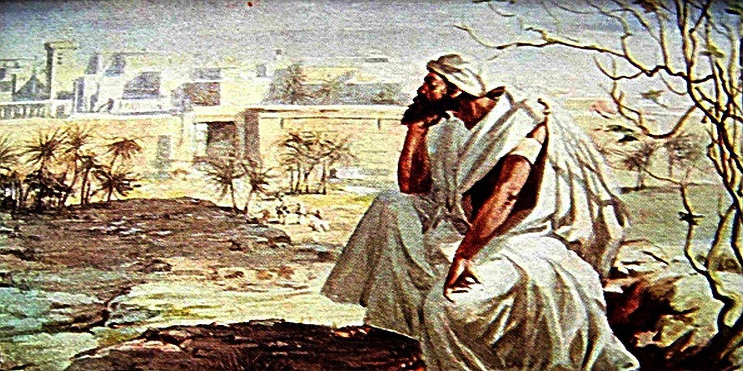

What Jonah is missing is the big picture. An astounding event has taken place, right in front of him. The Ninevites have decided to repent, en masse, all 120,000 of them. Israel’s biggest enemy has fallen to its knees, covered itself in sackcloth and ashes to beg for forgiveness from Israel’s God. They are no longer an enemy, they now answer to the same God. For anyone walking by, this would be as big a miracle as seeing the city destroyed. Bigger, even, since God didn’t make it happen. Astounding.

But Jonah can’t see it. He is stuck in his anger, his focus is stuck in that narrow perspective that comes with being angry. He is nursing his anger, ruminating on it. It is like that worm, which Gods send to the bush over Jonah’s head. Overnight, it quietly eats away all the green leaves. Because that’s what anger does when we let is fester. It doesn’t work quickly. It just settles in, feeding on resentments. First one, then another. If you have ever been in an argument with someone who holds a grudge against you, they start by complaining about one thing, and then something else, and something else. Their anger is hungry, like a worm, and wants to feed itself, to keep alive. This kind of bitterness stays in that narrow focus of anger, and gets stuck.

Earlier I mentioned that this story started out epic in scope, but ends on a very personal note. So, I would like to do the same thing today. Please take the leaf you have plucked off our fake tree here, and place it in your hand. [People came up earlier in the service to take a leaf each off the tree]

Now, with the leaf in your hands, I would like you to close your eyes. Think of someone against whom you have some kind of resentment. Perhaps they insulted you, or they are a family member who you feel has done you wrong. If you can’t think of anyone you bear a grudge against, think of someone who does hold a grudge.

Now open your eyes. Let the leaf represent that grudge, either your own, or someone else’s. Was it easy to think of one? Most of us have people or situations where we are stuck. Our anger is has become like that worm, wanting to stay alive, rather than cooling off. So, it settles in, as a grudge. We can forget about it for a while, but when that person or situation comes up, we remember the bitter feelings all over again.

How do escape a grudge?

So the question is, what do we do to get rid of these grudges? They are of no use to us – most of the time, the people we bear resentment towards have no idea what we’re feeling. There’s a saying about this – resentment is a poison you drink, expecting the other person to get sick.

The Jonah story provides a way out of this resentment. God says to Jonah, look at how upset you are about this bush dying, and now you are baking in the sun. If you care so much about this bush, which came and went in a day, consider how upset I must be about the Ninevites. There’s 120,000 of them, and I, God, wish they could be good people. But instead, they don’t know their right hand from their left – that is, they have no moral sense.

God is asking Jonah to consider this problem from another point of view – to see it the way God sees it, which is from a much broader perspective. If the problem with anger is that it causes to think too narrowly, God is suggesting that the antidote is to try to imagine the situation from a much broader perspective.

Hands up if you have ever been driving and you did something which made another driver upset. Perhaps they honked at you. Right, most of us have been in that situation. Now, keep your hands up if you felt really bad about it for days afterward. ( Most hands go down). Interesting. I suspect the reason you got over it so fast is that you were able to put what you did into a broader context. You may have cut someone off because you really were in a rush – there were kids to pick up, or a plane to catch. Or maybe you’d just had a bad day at work, or at home, and it left you impulsive. The point is, you can forgive yourself easily because you know the big picture of your own life. But to the driver who is honking at you, you are just the person who cut them off. They don’t know anything else about you. They have a narrow perspective, whereas you have a perspective that is more like God’s – a very broad one.

When we get stuck in bitterness thinking about a person or situation, we are the ones who are suffering first, and it is in our interest to get out of this rut, to stop the worm that is eating away at us. God tells Jonah to think about this situation from a much broader perspective. And, indeed, this whole story has given us a surprising view of the pagans. When the storm hit the ship, they didn’t act like villains, they were good human beings, trying hard to find a solution without anyone getting hurt. They threw Jonah over board only as a last resort, and at his insistence. In Nineveh, these sinful people listen to God, and repent. The story itself is suggesting that the bad guys are not actually all bad. They have their good side, too. The story is encouraging us to see another people with compassion, and not as black and white villains.

So now, let’s turn back to our leaves. Let’s see if we can take God’s advice to Jonah, and apply it in our personal lives. I’d like you to close your eyes once more. Think again about the person or situation you had in mind before. This time, try to imagine them in a broader context. What the rest of their life might be like, when they are not doing the thing which hurt you. Try to imagine them as God sees them, as living a full life, which is about more than just their interaction with you. They may still be wrong in how they treated you. But try to see them as full human beings, not to erase the wrong, but to dispel your anger and bitterness. Try to think about that later today, too, perhaps before you go to sleep. Try to see them as God sees them – flawed, but worth saving.

Now, open your eyes. I would like you to get up, and bring your leaves to the front, and re-attach them to the tree, as a sign of reconciliation. Of putting your grudges away, absorbed back into the greater whole.

Anger is meant to be an emotion that lasts only a short while, to help us deal with situations briefly. When it festers, it makes us turn inward, and distances us from each other and the world around us. So, let us accept God’s advice to Jonah, and take it for us. Let us remember that God offers us a full life of love and joy. Bitterness and anger are not meant to last, but to be fleeting, like a sudden storm that passes. God wants us to thrive, for if God can want to save sinners like the Ninevites, then we too, are heirs of that love. Amen.

Erin Carson, "This is your brain on hate," C/Net July 8 , 2 0 1 7
R. Douglas Fields, Why We Snap,( New York, 2015), 35.
R Douglas Fields, Why We Snap,( New York, 2015), 36.
R Douglas Fields,44.
Philip Gable and Eddie Harmon-Jones , “The Blues Broaden, but the Nasty Narrows: Attentional Consequences of Negative Affects Low and High in Motivational Intensity” Psychological Science, Vol. 21, No. 2 (February 2010),211.
Specifically, the left hemisphere’s prefrontal cortex.

