“Slave Labour”

Rev. Stephen Milton
Lawrence Park Community Church

September 1st, Labour Day, 2019
Reading: Paul’s letter to Philemon.

Happy Labour Day weekend everyone. It’s nice to get a long weekend right at the end of summer. This weekend was originally conceived by labour unions as a chance to relax, but also a chance to remember the achievements of the labour movement. Thanks to their efforts in the 19th and early 20th century, we get two days off a week, children no longer have to work in factories, and no one has to work twenty-four hours a day. It took many years of strikes to get the workday down to eight hours, an achievement that is always under threat, by management and often ourselves, as the cult of productivity whispers that we need to work to have our identity.

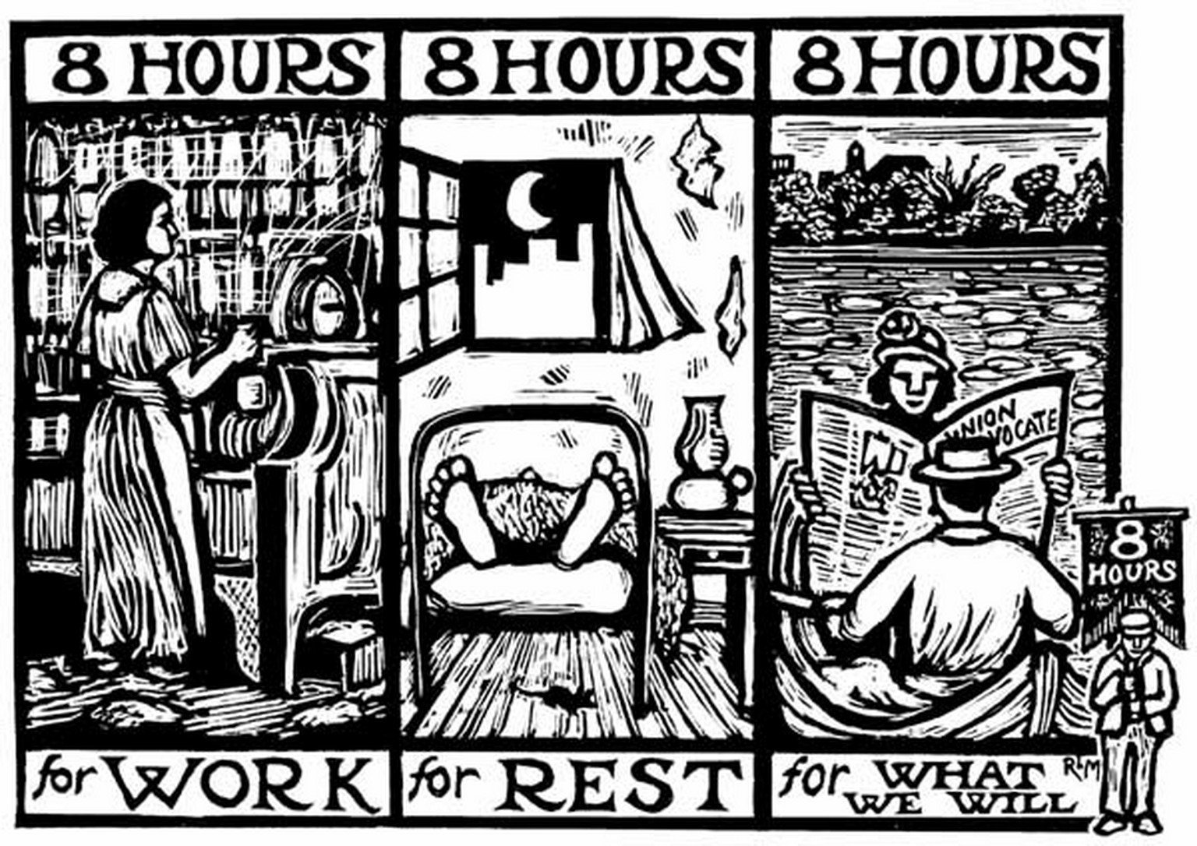
Since it is Labour Day weekend, it seemed like a good time to hear a scripture passage which is about what work used to be like before unions. In the passage that John read, we hear that the apostle Paul is once again in jail. He’s offended the local religious authorities with his idea that Jesus was the Messiah. But jail back then didn’t provide food and clothing. Your friends and family were supposed to supply those things, so Paul often has visitors in his cell. And on lately, he tells us, his companion has been an escaped slave called Onesimus.

This letter is really about three people: Paul, Onesimus and his owner, Philemon. So, to keep track, let’s use these three chairs. We know a lot about Paul. He would have been sitting in jail with a shirt, a tunic, and some shoes. The enslaved man, Onesimus is more of a mystery. As a slave, Onesimus would have had ratty clothes, and pro1bably just the tunic, no coat or cloak. Slaves who were caught running away from their masters could be killed, or, if they were returned to their masters, the words for “runaway” would be tattooed on their foreheads. So we can assume that since Onesimus has reached Paul for help, he probably doesn’t have any tattoos - yet.

There is another person in this letter who we do not see - Philemon. He is a Christian, probably brought to the faith by Paul. He owns Onesimus. That means he can whip, beat, tattoo and even kill his escaped slave, all of which will be perfectly legal. Onesimus may also be a Christian, converted when Philemon converted - entire households tended to convert at the same time. So, this escaped slave knows Paul is a compassionate man, who is willing to break rules. Afterall, he brought Christianity to the Gentiles, told them they did not need to be circumcised to join this new kind of Judaism. Paul has shocked his contemporaries by breaking all sorts of rules - that’s why he keeps getting thrown in jail. Maybe he will be sympathetic to Onesimus, too.

It’s a good bet, because Paul does suggest to Philemon that he take Onesimus back, and he even hints that he should set this slave free. But to modern ears, it is what Paul doesn’t say which matters most. Here, in a letter preserved in the New Testament, the shortest letter of all, the one thing he does not say is that slavery is wrong. That slavery as an institution should be dismantled. That slavery is against everything Christ stands for. Instead, he suggests that this slave should be set free, but not what we most want to hear, which is that all slaves should be set free.

Paul Causes A Problem for Us

Paul’s refusal to condemn slavery has caused huge problems for ancient society, and for ours. In the years that followed, Christianity took over the Roman empire, but it never gave up on slavery. Christians decided that Christians shouldn’t be enslaved, but that meant it was permissible to enslave non-Christians. Overall, as the centuries passed by, the practice of slavery dropped, often down to nothing in some places.

But when Europeans discovered the New World, slavery was brought back in full force. The Spaniards enslaved the pagan Indigenous people of the Caribbean and South America. When Europeans diseases and exhaustion decimated their populations, Black Africans were kidnapped from West Africa, and brought in as slave labour. Some Catholic missionaries protested against the cruelty of slavery, but few argued about whether slavery was allowed.

In Canada, when we think about slavery, we tend to think about the American South. There, vast plantations were populated by enslaved Africans, who lived and died under a cruel and harsh regime of racial slavery. Whites in charge, Blacks enslaved. As Canadians we take pride in the fact that when enslaved people escaped from the South, they tried to get here via the Underground Railroad.
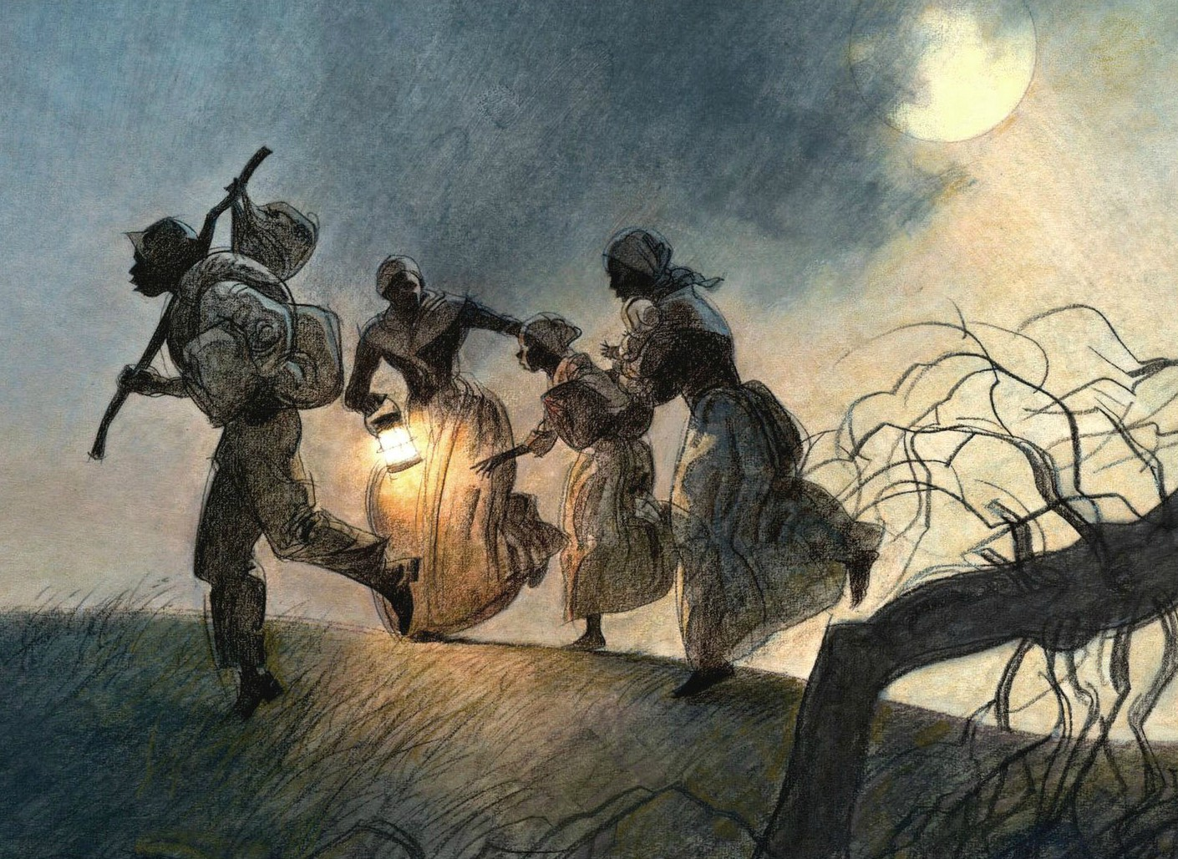
Canadian slavery
However, what we forget, or don’t know, is that for 200 years, slavery was perfectly legal and practiced here in Canada. When the French settled Montreal and Quebec, they used slaves to do it. In Quebec, slaves were a mix of Indigenous people and Black Africans. Unlike the deep south, our climate didn’t allow plantations, so the economy was initially based on the fur trade. This entailed sending men out to work alone for months at a time, a recipe for escape if you were a slave. So, instead, most slaves in places like Quebec and British Nova Scotia were employed on small farms and in city homes. Many leading citizens had slaves. James McGill of Montreal, the founder of McGill University, was a slave owner. So was William Jarvis, of Toronto. We like to think of ourselves as the good guys in the slavery story, but in the 16 and 1700s, slavery was just as common up here as it was in the South. The fact that we are not taught this is one way in which Canadians cover up and hide our racism.

The reason slavery was so common in the United States and Canada was because the Bible said it was okay. Paul didn’t come out against it, and neither did any other part of the Bible. So, for upstanding Christian citizens, there simply wasn’t a problem. However, in the late 18th century that started to change. Some Christians were offended by the wanton cruelty meted out against slaves - the beatings, the whippings, the executions.

One of them was Lord John Graves Simcoe. You recognize the name - every southern Ontario small town and City has a Simcoe street. He was Ontario’s first Lieutenant Governor. He arrived in 1791 from Britain, and he was the one who founded Toronto. Thanks to him, we are all here today.

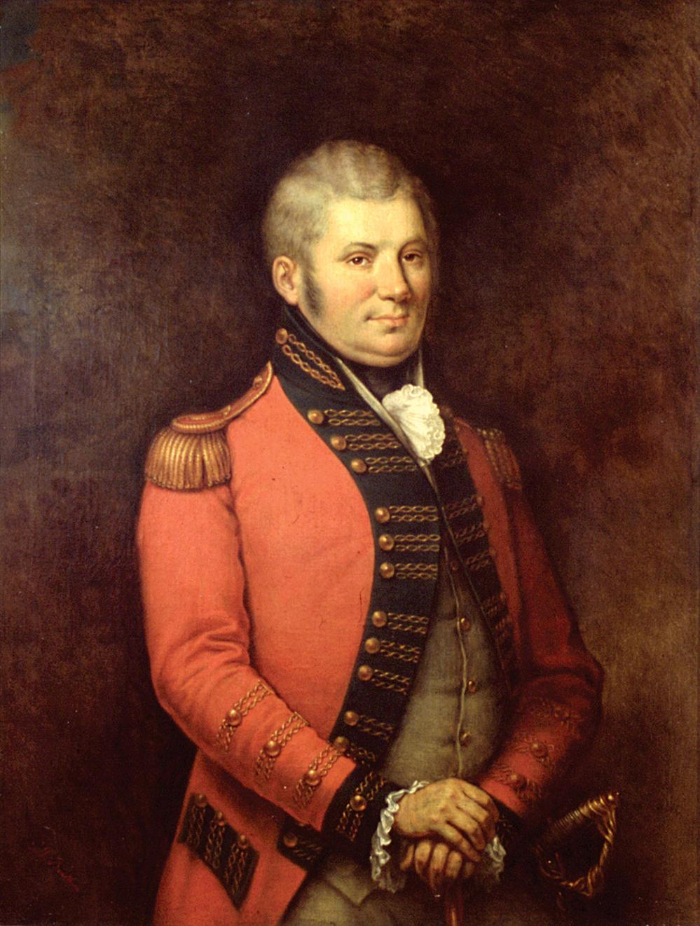
Simcoe arrived at a time when the streets of the town of York down by Front Street would have been home to many Blacks slaves working for the wealthy families here. And that disgusted him. He felt slavery was both evil and unchristian. So, to his eternal credit, he decided to outlaw slavery in Ontario. But he had a problem. He needed to get a bill passed through the legislative Council, which was populated by rich white men - women and slaves were not allowed to vote. Many of these white men were slave owners, who would vote against giving up their slaves. So, in 1793 he proposed a compromise: that slaveowners keep their existing slaves, although any child born to a slave be set free as an adult. The bill put an end to new slaves coming into Ontario, and those who escaped to here would be free as soon as they crossed the border. It was thanks to Simcoe that Ontario became a safe place to escape to. In the rest of Canada, slavery remained legal until the British empire outlawed it in 1834. So, thanks to Simcoe, Ontario was ahead of the times.
Lt Gov. John Graves Simcoe

Simcoe had the personal and political power to push through his personal views, but in the United States, it was not so easy. Citizens and clergy alike in both the North and South saw slavery as allowed by Christianity. When Paul had his chance to condemn slavery, he had remained silent when writing to Philemon.

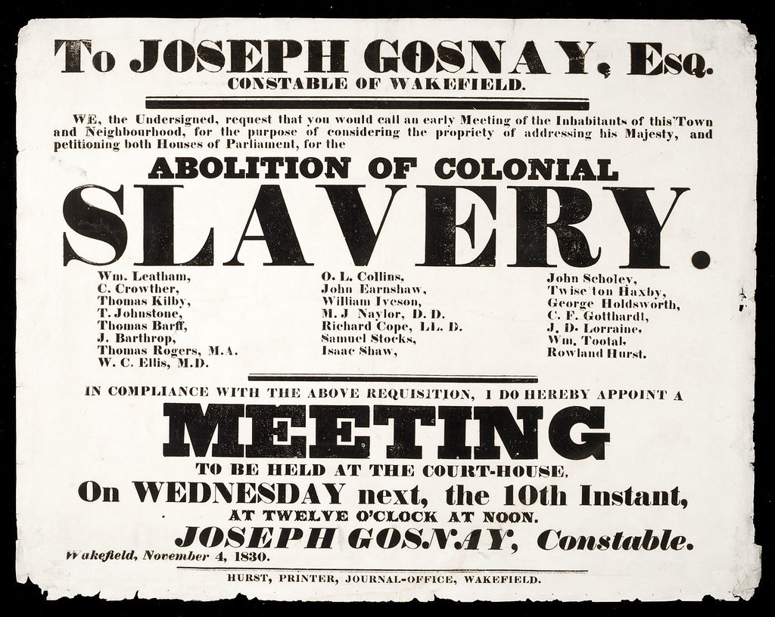
But, like Lord Simcoe, some Christians in the United States found slavery disgusting. In the 1800s, a growing movement of Christians called for the abolition of slavery - they were known as abolitionists. But they had a problem. To convince the rest of America, they needed to argue that the Bible was against slavery. And that was tough. They tried many different arguments: that each time we hear the word ‘slavery’ in the English translation, it really means ‘servant.’ Biblical scholars quickly dismissed that argument. Then they argued that the reason Jesus didn’t condemn slavery was that it didn’t exist in Israel in his lifetime. That was also incorrect. In the end, they settled on a very different argument. They said that although no single sentence in the Bible condemns slavery, the overall spirit of Christ’s message does indicate that slavery is wrong. That Christ’s love for the poor and oppressed planted a seed of radical compassion in human history that was progressively overturning social injustice. The entire Bible is a testament against slavery, even if it never says so in any one sentence.

Literal Readings This embroiled the entire American nation in a debate over how to interpret the Bible. For proslavery Christians, the Bible had been written so that anyone could read it and understand it. It was written in plain sense, and it was meant to be read literally. It was truly an open book anyone could understand. If Paul didn’t condemn slavery in his letter to Philemon, it was because he approved of it. Case closed.

‘Meta’ view of the Bible. The anti-slavery Christians argued that we shouldn’t read the Bible that way. It needed to be read with a sense of moral intuition. God’s overall message through Jesus Christ was that compassion and love should be offered to all, even if it meant going beyond what was considered acceptable back in Biblical times.

Just get rid of the Bible. And a few Christians took a third position. They argued that since the Bible could not provide unambiguous support to ending slavery, and was silent on other modern issues, like emancipation of women, the Bible should simply be set aside. It was no ally at all.

The Origin of Today’s Approaches to Christianity

Sound familiar? The positions staked out in the slavery debate laid the foundation for the kind of Christianity we have today. Southern evangelicals have continued the proslavery tradition of arguing that the Bible should be read literally, in fact, it was designed so it could be read literally to provide answers to anyone’s questions, in any century. This approach, which was defended during the slavery debate, has been used to define the evangelical position on abortion, homosexuality, and the rights of women, right up until today.

For the abolitionists, a new kind of Christianity was needed, one that was not tied so closely to the Bible. They needed to be able to read the Bible in a meta way, to see the overall pattern of liberation, without getting hung up on the details of any particular passage. They broke with biblical literalism, and forged the way for the kind of Christianity which we practice in the United Church today. We don’t expect to find support for the rights of homosexuals in specific lines of the Bible. Indeed, when this congregation decided to go down the path of becoming affirming, you did it with a confidence that you were working within the spirit of Christianity, if not the letter of the Bible’s passages. That tension will be something that you will encounter more in detail as you discuss was being an affirming congregation means.

And lastly, in the 1800s, some said, let’s just put the Bible aside all together in our quest to pursue justice. Let’s rely on our principles and conscience alone. That was a minority position in the slavery debate, but has since become a much larger part of our society. Today, 29 percent of Millennials report having no religious ties at all. Less than 13 percent of Canadians attend church weekly. Most people make their decisions not based on the spirit or letter of the Bible, but based on abstract principles of justice and personal conscience.

Our spiritual landscape was largely created out of the fight over slavery in the 19th century. All because Paul did not condemn the institution of slavery in his letters. Imagine if Paul had said that God objects to slavery - it was a necessary evil in the past, but under Christ, it is no longer legitimate. Had Paul said that, the abolitionists could have easily won the debate - and still been literalists. But Paul didn’t condemn slavery. But he didn’t endorse it, either. In his letter, he clearly wants Philemon to take the Christian hint. That Onesimus deserves better. That he, like Philemon and Paul, deserves to be free. But Paul leaves the choice for Philemon to make. And now, we are like Philemon. We have been given the choice of how far we will apply the values contained in the Bible. Will we try to live according to the rules and values of ancient society, as a literal reading would have it? Or will we try to discern what Christ is leading us to do in situations never imagined by the Bible? Or, will we cast the Bible aside and go on our own?

The letter to Philemon gives no hint of what happened to Onesimus. However, later church histories record that there was an early bishop in the church called Onesimus. It was believed that this was proof that Paul was able to convince Philemon to set his slave free. It’s hard to know. As often happens, Christianity does not provide certainty, but direction, which relies on personal conscience to become action. The Bible is not a rule book, but it can provide guidance and wisdom - and a star to aim for as we travel through dark times, something escaping slaves knew very well. Amen.

Sandra R Joshel, Slavery in the Roman World, 132.
Sandra R Joshel, Slavery in the Roman World, 119.
Joshel, 121.
Jeffrey Fynn-Paul, “Empire, Monotheism And Slavery In The Greater Mediterranean Region From Antiquity To The Early Modern Era,” Past & Present, No. 205 (NOVEMBER 2009), 16.
One of the first Christian priests to condemn the enslavement of Indigenous peoples was Bartolome de la Casas, A Short Account of the Destruction of the Indies, written in 1542.
Jason H. Silverman, Unwelcome Guests: Canada West's Response to American Fugitive Slaves 1800-1865, (New York, 1985)1-5. By 1760, there were 1100 Black slaves in New France.
https://www.theglobeandmail.com/opinion/200-years-a-slave-the-dark-history-of-captivity-in-canada/article17178374/
https://www.huffingtonpost.ca/2017/06/17/slavery-canada-history_n_16806804.html?guccounter=1&guce_referrer=aHR0cHM6Ly93d3cuZ29vZ2xlLmNvbS8&guce_referrer_sig=AQAAAM7rLvFRtpT4IywgkZIS-rLep7Lpnt3dEyGB_BJM6_sX75yg-tbJgomU5k-YP3wJ_vFxtyrF-d8w7HptkrQ6YVv1Buk4RvaCbQndrf0qXMZlDSh6s0lYO6Gh8OQFVDvQMQrs1CfpSvJTV5FeZYUkKlFDLOl1S1K5J30XsL9sOBXC
Jason H. Silverman, Unwelcome Guests: Canada West's Response to American Fugitive Slaves 1800-1865, (New York, 1985), 7ff.
Jason H. Silverman, Unwelcome Guests: Canada West's Response to American Fugitive Slaves 1800-1865, (New York, 1985),8.
https://www.pbs.org/black-culture/shows/list/underground-railroad/stories-freedom/abolition-slavery-canada/
J. Albert Harrill, “The Use of the New Testament in the American Slave Controversy: A Case History in the Hermeneutical Tension between Biblical Criticism and Christian Moral Debate,” Religion and American Culture: A Journal of Interpretation, Vol. 10, No. 2 (Summer, 2000), 151.
J. Albert Harill, 153ff.
J. Albert Harill, 164.
J. Albert Harill, 173.
Ellen Samek, “The Canadian millennials choosing God in a secular world,” National Post, March 4, 2019.
https://www.intrust.org/Magazine/Issues/New-Year-2016/Religious-affiliation-and-attendance-in-Canada

