Butterfly Saints
A sermon preached at Lawrence Park Community Church, November 3, 2019
Psalm 8
Rev. John Suk, Ph.D.

An eighteen-wheeler semitruck has, well, eighteen wheels. Each one is important. If you ever find yourself driving down the highway in a semi you wouldn’t want any of those tires to go flat.

But, perhaps more than any of the others, you want the semi’s two front two tires to stay on track. If one of those blows it will be very hard, perhaps impossible, to steer. Blow one of your front tires and you may have an emergency on your hands.

That is how it is for me too. I have at least eighteen interests: family, literature, birds, sailing, theology, and more. I like them all. If I had to drop any one of them, I’d be sad. But two of my interests have steered me, as a minister, more than the others. One is a hobby—evolution. The other is a passion—preaching.

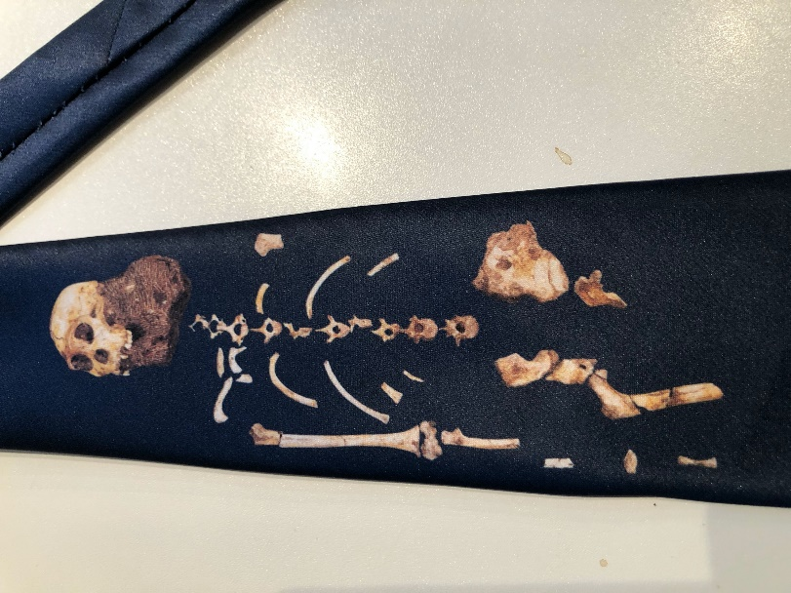
So first, evolution. Evolution is the slow process by which genetic mutations have transformed ape-like creatures that lived millions of years ago into modern humans. It’s a theory, of course, like gravity is a theory.

I have always been utterly fascinated by evolution. One of the highlights of my sabbatical, five years ago, was the opportunity to visit the Cradle of Humankind, near Pretoria in South Africa. Many ancient human fossils have been found in the limestone caves there. I crawled through those caves, deep underground, where archeologists were still working.

I also picked up the skeleton tie I’m wearing today (not a Halloween tie!) at the Cradle of Humankindmuseum. It shows the skeleton of an individual from a species known as Australapithicus Sebida. This person lived about two million years ago, walked on two feet and used stone tools. We can’t be sure whether or not Sebida was a direct ancestor to humans, but if it wasn’t, Sebida is a first cousin.

This next picture is of a Homo Rudolfensis individual, who lived at about the same time, but in East Africa. The pictures I’m showing today are facial reconstructions based on the shape of the bones and marks left by ligaments. It’s a process much like that police use to reconstruct the faces of people whose bones have been found but can’t be identified. Scientists are pretty sure that our species, Homo Sapiens, is descended from Homo Rudolfensis.

Rudolfensis, like Sebida, used stone tools—scrapers, knives, and axes. The shape of their teeth suggests they ate meat, but it was likely raw because there is no evidence they used fire. It doesn’t sound like great cuisine, but then, you know, some people still eat sushi. According to Psalm 8, humans are “a little lower than God.” Sebida and Rudolfensis were on the way—but they certainly did not yet have the dominion over creation the Psalmist claims for us.

The next picture is of Homo Naledi, a human species discovered in the Cradle of Humanity not long after I visited there. We are not descended from Naledi. They are another cousin species, like Sebida. This person lived about 350,000 years ago, and compared to us, had a much smaller brain. A large number of individuals were found buried in a cave far underground, suggesting that they were deposited there ritually. And, they must have had portable fire to get so far below, in the dark. That would have been an impressive technological development. But, like Sebida and Rudophensis, Naledi is extinct. Human species do go extinct. Many already have. Think about that.

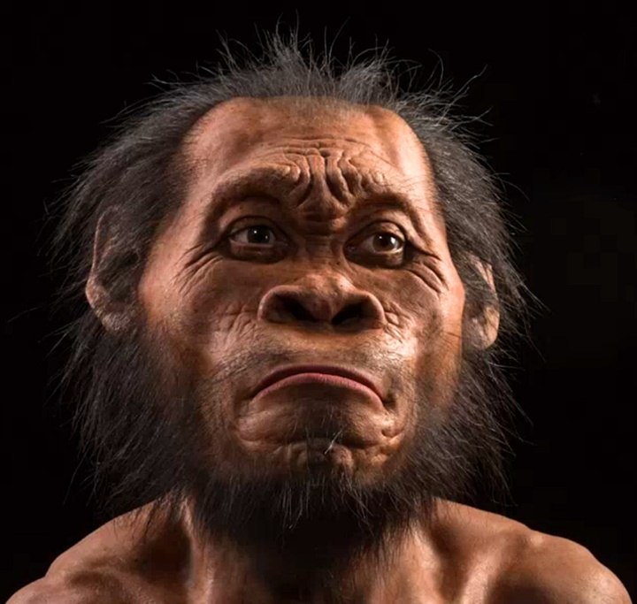

The last picture is of a Homo Neanderthal individual. Neanderthals are our kissing cousins because we Homo Sapiens sporadically interbred with them. Most humans outside of Africa have some Neanderthal genes. Neanderthals showed up in Europe about seven or eight hundred thousand years ago, and went extinct about 35,000 years ago, just a few thousand years after Homo Sapiens arrived in Europe. That means that Neanderthals were in Europe fourteen times longer than Homo Sapiens, us!
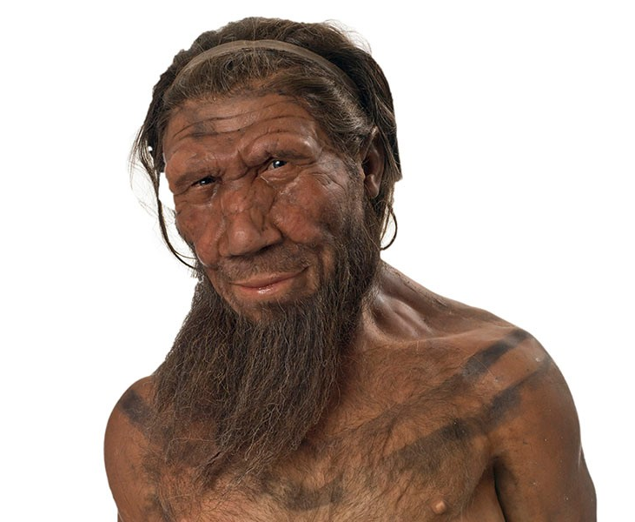
While Neanderthals look primitive due to their huge nose and eyebrow bones, they used fire, managed to live in cold climates by sewing together clothes, had complex tools, and took care of their aged and wounded even when they could no longer work. Because they buried their dead with rituals and plants, Neanderthals probably had beliefs about an afterlife. They made jewelry and flutes. Still, as far as we can tell, Neanderthals never domesticated the Psalmist’s sheep and oxen, and other beasts of the field.

Our species is named Homo sapiens—or, translated from the Latin, “wise humans.” Not only do we control fire, we split atoms. We have perfected the technology of healing human bones, reading them for ancient DNA, or replacing them when they wear out. We live in unimaginable comfort and ease compared to Neanderthals. And, for better or worse, we do have dominion over all the earth and everything in it, and we do have god-like powers with respect to the earth, just as the Psalmist suggested.

Unfortunately, we have also been implicated in the extinction of countless species of birds of the air and fish of the sea—never mind plants of the earth. We are changing the climate of the planet, perfected racism and genocide and nuclear annihilation as political tools, threatening ourselves with extinction. We can feed everyone on our planet, but don’t. We have the capacity to think morally, about what is right and wrong, but often refuse to do so in the search for short term gain.

I said we have the capacity to think morally. That brings me to the second wheel that steers my semi. It’s preaching. My PhD is in speech communication. I’ve taught preaching in seminary. And one of the most difficult problems I face as a preacher has always been the problem of nagging.

You see, I am convinced that Jesus is a model for human morality. But that means when I get into the pulpit, I’m also tempted to tell you what to do, you’ve heard that before. Imitate Jesus, be courageous like Jesus, heal like Jesus, love like Jesus, fight injustice like Jesus, treat the poor like Jesus. Every Sunday. Just go, go, go, and if that is my message, week in and out, I am going to sound like a noisy gong or clanging cymbal, a nag. You are going to feel inadequate because no matter what I say, you know you can’t do it all, always, as well as Jesus.

So today, using my first interest, evolution, I want to suggest a way of thinking about my second interest, that will help get at solving the nagging problem. It’s called the Butterfly effect. Two science fiction writers, Terry Pratchett and Neil Gaiman, put it this way in a recent book, Good Omens. Quote:

It used to be thought that the events that changed the world were things like big bombs, maniac politicians, huge earthquakes, or vast population movements, but it has now been realized that this is a very old-fashioned view held by people totally out of touch with modern thought. The things that change the world, according to Chaos theory, are the tiny things. A butterfly flaps its wings in the Amazonian jungle, and subsequently a storm ravages half of Europe.

The butterfly effect t is obviously much more complex than that and it has received a lot of attention recently, especially by both social and hard scientists. Basically, the theory recongizes that small, unpredictable events often have a huge impact down the road. For example, what if Hitler had succumbed to an infected wound during World War One? What if a Viking fisherman, five hundred years before Columbus, in Newfoundland, had passed on European diseases to First Nations back then, so that by the time Columbus arrived, western diseases might not have devastated the Incan civilization?

There is an ancient proverb that gets at this mystery. It is about the nail that fastens a horseshoe to a hoof. It goes like this:

For want of a nail the shoe was lost.
For want of a shoe the horse was lost.
For want of a horse the rider was lost.
For want of a rider the message was lost.
For want of a message the battle was lost.
For want of a battle the kingdom was lost.
And all for the want of a horseshoe nail.

In an analogous way, the accumulation of small, evolutionary changes, and the accumulation of the events of our ancestors’ lives, has made humans—both with our good traits and our bad ones—what we are today. We are who we are, in part, because of a million, billion butterfly wing flaps by countless nameless saints through the millennia.

And now, when it comes to the planet, to how we act at work, to how we educate our children, to how we spend our cash—our small and unpredictable actions are also what the future of the human race will rest upon and be determined by. Never let anyone tell you that you can’t make a difference. Don’t let anyone try to convince you that your contribution has to be heroic, or it won’t make a difference.

Wrong. The accumulation of our simple actions, over the course of our lives and magnified by many other actions by many other people over thousands of generations will change the world we live in, often in unpredictable and potentially beautiful ways—especially when we do good, moral things to nudge the world into its full potential glory.

We face huge challenges. We are overwhelmed, individually, by climate change and racism, by our new social media habits and fake news, by homelessness in the streets and plastic in the ocean. And not one of us can solve these problems alone.

But again, the lesson of human evolution is that bit by bit we do change, and cumulatively, we can transform the human prospect together, keep our rig on the road, by trying to be like Jesus in the small things first. And over time, our culture and we as humans will evolve. It’s following Jesus together, especially, that can transform the world, one breath and action at a time, in unpredictable ways.

So, don’t lose heart if Stephen or I nags you too much, at least occasionally. Don’t imagine that you really have to be the hero who does it all by yourself. Just try to follow Jesus today. Starting with the small things. Those are the actions that will determine the future of our world.

