“Remembering and Forgetting”
Soul Table sermon – Stephen Milton
Nov 10 2019

Tomorrow is Remembrance Day. It’s a day devoted to remembering the sacrifices and service of all those who have defended our country in wars present and past. All over the country people will be laying wreaths and observing a minute of silence in their honour. It’s good that we do this, but it is also deeply ironic. Remembrance Day comes at a time when in our daily lives it is getting harder and harder to remember anything. The digital age that we are now living in has changed the nature of how we remember. The good news is that we now have access to more information than any other generation in human history. There was a time when a big library consisted of one hundred books. Now, anyone with a computer can have access to pretty much everything that was ever written or recorded up to a few years ago. And, if you’re young, you probably know how to hack into the rest of it through bittorrent.

The paradox is that with all that information at our fingertips, we personally are remembering less and less. There’s no need to memorize anything anymore, since we can always access it online. Kids don’t memorize much, if anything, in school. Even those of us who are well out of school are losing our memory for common things.

Let me show you what I mean. Think of the four people you call most frequently on your cell phone. Ok, so now, let’s do a little test. Raise your hand if you remember your own cell phone number. (Most hands go up). Good. Now, how many of you can’t remember the number of the second person on your list? No shame here, just be honest. Ok, raise your hand if you can’t remember the numbers of the third person on your list. Uh huh, that’s most of us. The fourth? ( most hands are now up).

There’s no reason to feel ashamed, this is how it is for most of us now. Our phones are doing the remembering for us. It’s just easier to program the number in and forget it. I do it, too. I have no idea what my kids’ phone numbers are, even though I text and call them all the time. But the problem isn’t with our memories. How many of you can remember any of your phone numbers from when you had landlines? Most of us, I suspect.

The “Magic” Number 7

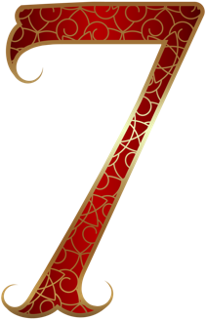
And that’s not surprising, because phone numbers are designed to be easy to remember. Human memory is divided into two types – working memory, and long-term memory. Our working memory is what you use when you learn something like a phone number for the first time. We take that information and stick it into long term memory if we decide, consciously or unconsciously, that something is worth remembering for a long time. The trick is that our working memory can only store up to seven pieces of information, plus or minus 2. So, when phone numbers were designed, over time they evolved to become just seven numbers. Because we can remember a bit more, area codes can be added, which are easy to remember because they are the same for everyone within that region, so they count as one piece of information.

This ability to remember 7 pieces of information easily has deeply influenced human culture and history. You can see this over the past few thousand years. There are:

7 wonders of the world; 7 seas; 7 days of the week; 7 deadly sins; Snow White and the 7 dwarves.

It’s not that the number 7 is magical. It’s just the maximum number of pieces of information most of us can remember easily. We can also remember smaller numbers under 7. You see this clearly in the world’s religions:

In Islam, there are the 5 pillars; In Buddhism there are the Four Noble Truths. In Christianity, there is the trinity and the four gospels. The Jews gave us the ten commandments. Perhaps the reason the world is so messed up is that most of us can’t remember them all!

Our memories are built to remember up to 7 things, but of course the world comes in combinations of more than 7, so people have needed to be able to remember much more than that. In the past, people could and did memorize entire books. This was simply part of what educated people did – they read books and knew how to remember them. But how?

Spatial Memory

It turns out that we humans have lousy memories for learning lists of new information, but we have great spatial memories. Spatial memory is our ability to remember the places we have been. We memorize places spontaneously, without any effort. Let me show you how you have already done this tonight. I am going to give you a test, and each time most of you get the answer right, I will ring this bell. [ ring it].
Ok, I’d like everyone to close your eyes. Imagine that you are in the parking lot of this building. You walk towards the front doors, like you did a little while ago.

Look at the doors. Lift a fist if they are made of wood. Ok, now lift your palm if they are made of glass. [ ring bell].Keeping your eyes closed, you enter the foyer. There is a greeting table where people stop to write their names on tags. Is the table on your left or your right as you walk in. Lift a fist if it is on your left. Ok, now, lift a palm if it is on your right. [ ring bell]. Another: to get into this room, you had to walk up a ramp. Do you turn right or left to get onto the ramp? Put up a fist for turning left – now put up a palm for turning right. [ ring bell] One last one. You’re in this room. One of the members of the band has a dark beard. Does he play bass or drums? Fists up for drums – palms up for bass. [ they may get this one wrong].

So, you got all of the spatial memory questions right, but you had a much harder time with a memory about a person. Our spatial memory is excellent, without even trying. We remember where we walk much easier than what we have to memorize on purpose. Even better than remembering faces. This skill was noticed over 2500 years ago, and became the basis of a technique known as the memory palace.

Legend has it that this technique was discovered when an earthquake destroyed a building where a banquet was being held. Just by chance, a poet who had performed to the guests a few minutes before had been called outside before the building fell down. When people ran up to the building looking for their loved ones under the rubble, he closed his eyes. He thought back to what the banquet looked like from the inside. He could see everyone in their seats. When he opened his eyes, he led the relatives and friends to the places in the rubble where their loved ones had been sitting.

What Simonides realized was that spatial memory is better than abstract memory. He could see in his mind’s eye the location of each guest, just as you can remember the location and appearance of the doors and tables here, even if tonight is your first time here. So the Greeks developed a memory technique which piggy backs on our spatial memory. It works like this. Say you have to remember a list of information like this one:

Salmon
Garlic,
6 bottles of champagne
Dinosaur.

Instead of trying to memorize it line by line the hard way, try placing each object in a place you already know really well.

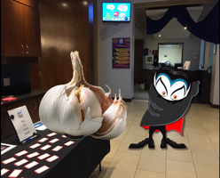
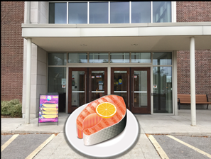
So, the salmon goes beside the outside doors of the church;
the garlic on the greeting table,with Dracula afraid of it. This works better if you make it extreme of goofy, since the goal is to remember it.
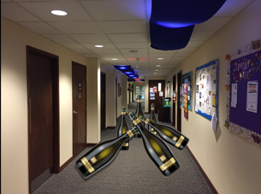
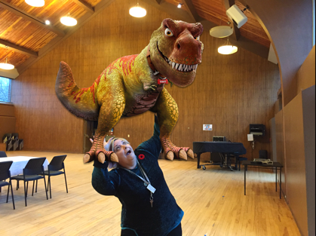
The six bottles are in the hallway, as though someone has been bowling with them;
and the dinosaur is on top of Judi. The crazier the better.

Why memorize anything?
This technique and others were used in old days to memorize entire books. It was normal for educated people to carry entire libraries in their heads, which meant that they could pluck a prayer or a piece of wisdom out of their memories at any time. And that can be a source of great consolation. When I went on a spiritual pilgrimage this year, on the Camino in Portugal, I wanted to pray every day. But I didn’t want to carry a Bible with me, because we were backpacking. So, I memorized some prayers, which we said in little chapels along the way.

Memorization has all sorts of unexpected uses. Long ago, I belonged to a church which included a big older woman in the congregation. She was an imposing presence. One day she told me that she was walking down the street, and a man tried to steal her purse. He grabbed it, and was pulling on it, and she didn’t want to let go. She was afraid he might hurt her, so at the top of her lungs, she recited the Lord’s prayer. Well, a big older lady booming the words of “Our Father” in broad daylight freaked out that thief, and he dropped the purse and ran away. This theft had suddenly become a cosmological event, and he wasn’t ready for that. The point is, she knew her prayers off by heart, so at that moment, she was that prayer, with all the power that is contained in it. When we memorize something, we become it when we perform it, which can be a source of power, and consolation.

Forgetting Day

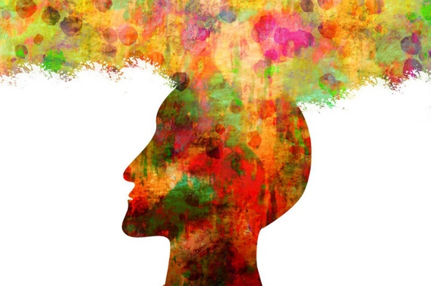
Having a good memory can be a great blessing, and it can be developed with practice. But on this Remembrance Day, it is also important to remember that memory can also be a curse. In fact, for many veterans, it might be more compassionate to call today Forgetting Day. It is estimated that up to ten percent of all active duty members in the Canadian army are suffering from post-traumatic stress disorder. Also known as PTSD, it is a mental state which is caused by exposure to an event which causes psychological trauma and emotional symptoms which persist. A bomb goes off suddenly on the road, flips your truck, hurts you and kills your best friend. The shock of the event persists in nightmares and flashbacks for years afterwards. Studies have found that 10 percent of soldiers have it, although everyone agrees that this is an underestimate since people with PTSD often quit the armed forces because they no longer want to work in the military. Often they find it hard to be employed in any line of work.

PTSD is a memory of something awful that continues to haunt a person, but in strange ways. Often, the event which causes the PTSD is poorly remembered. It is so upsetting that the memory shatters into pieces, and is only remembered in glimpses and chunks.

This is why testimony from sexual assault victims is often fragmentary. It is not the fault of the victim, but a function of how regular memory processes break down in highly stressful situations. Ironically, what does persist quite accurately, is the emotional memory of what the event felt like. The fear, the anger, the panic, all of that is preserved, and can come back at a moment’s notice when another event occurs which bears some resemblance to the original event. These are called triggers. These are usually benign – the smell of cologne reminds a person of their attacker; a loud bang caused by a car backfiring reminds a soldier of an explosion in wartime.

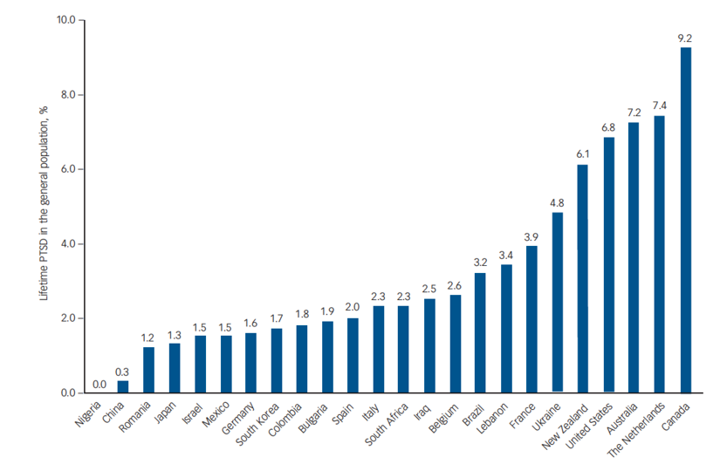
A few years ago, a study was released that ranked countries by the incidence of PTSD. Everyone expected war torn countries like Iraq and Syria to be at the top of the list. But the top-ranked country for the incidence of PTSD turned out to be Canada. That surprised everyone. Canada is a much safer country on pretty much all measures compared to Iraq or Afghanistan.

What puts us at the top of the list is not the number of trauma-inducing events, but how we deal with them. More people experience trauma in other countries, but they are surrounded by people who help them through it, who cry at the same funerals, and are willing to talk about it. In Canada, by contrast, we have a highly individualistic country where we value personal privacy very highly. If someone is raped, or is in a car accident, or comes home from a war with a devastating experience, we don’t encourage them to talk about it. Instead, we tend to recommend that they go into a room in private and talk about it in secret with a therapist. We put a cone of silence around trauma, exacerbating the long-term effects of memories that won’t go away.

We need to make space for people to be able to talk about pain publicly. And to recognize that despite all of our technological success, personal pain is still with us, and will be with us for the foreseeable future. Indeed, our technology, through the Internet, is making it harder for anyone to forget their past. Our past mistakes are caught on camera or in texts, and then get stored on servers all over the world. It’s getting harder for the world and individuals to forget. It is as though we have created a digital memory palace, where nothing is ever forgotten. That’s our new age. We have poor memories, but the internet has the best memory ever invented, and , unlike us, computers don’t know anything about forgiveness.

And that’s the step that can’t be missed. To be human is to balance forgetting and remembering. This city is full of people who came here because they wanted to forget about bad things that happened to them somewhere else. Both people born in other countries and those born here. There is no way that everyone will get a chance to get treatment for all of the PTSD that is floating around this city. So, we are going to need to be forgiving. To recognize that for some people, yelling at you when you bump into them may be the best they can do today. It’s not what our culture encourages. We’re always right. But if we get real, if we recognize that we are in a city full of people in pain, then maybe we can draw on our spiritual traditions to judge less, and forgive more. Because our computers won’t.

Joshua Foer, 58.
Joshua Foer, 147-9.
Joshua Foer, 95.
Joshua Foer, Preface.
https://www.veterans.gc.ca/eng/health-support/mental-health-and-wellness/understanding-mental-health/ptsd-warstress
Alain Brunet, PhD, Eva Monson, PhD, Aihua Liu, PhD, and Deniz Fikretoglu, PhD, "Trauma Exposure and Posttraumatic Stress Disorder in the Canadian Military," Canadian Journal of Psychiatry. 2015 Nov; 60(11): 488–496
Bessel Van der Kolk, The Body Keeps the Score,(Penguin, Canada, 2015), 193.
Michel Dückers et al, “A vulnerability paradox in the cross-national prevalence of post-traumatic stress disorder,” The British Journal of Psychiatry, July 2016.

