Rudolph, the Red-Nosed Camel
A Sermon preached at Lawrence Park Community Church, Dec. 1, 2019
Matthew 2:1-12
Rev. John Suk, PhD

Let’s be honest. If our children or grandchildren thought that three wise men visited Baby Jesus on Rudolph, the red-nosed camel, we would smile but hardly be surprised.

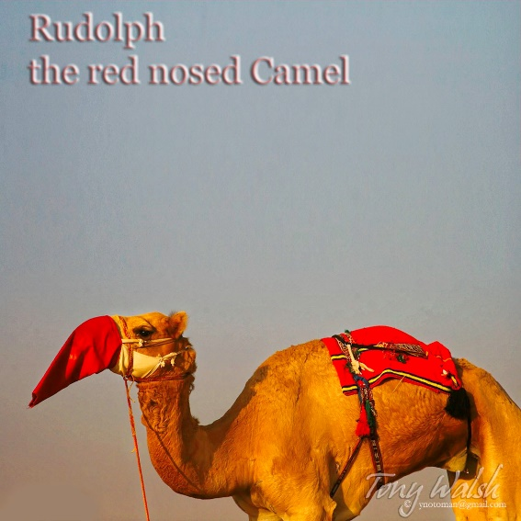

Or if the kids thought that angels serenaded shepherds in the field with a jingle bell accompaniment, we would smile, but hardly be surprised.

Christmas—that is, the religious celebration of Jesus’ birth, is almost history. It has been taken over by Santa, the Grinch who stole it, and big retail. This is the commercialization of Christmas and sometimes it makes the news.

For example, a few years ago, Starbucks celebrated the season by serving its Ventes in red cups. Some sippers were outraged, claiming that this—failing to mention Christmas on their cups—was a war on Christmas. Donald Trump addressed the cup controversy on the campaign trail. “Maybe we should boycott Starbucks,” he said. “If I become president we’re all going to be saying Merry Christmas again, that I can tell you.” Maybe. Maybe not. This year Starbucks cups say, “Merry Coffee.”

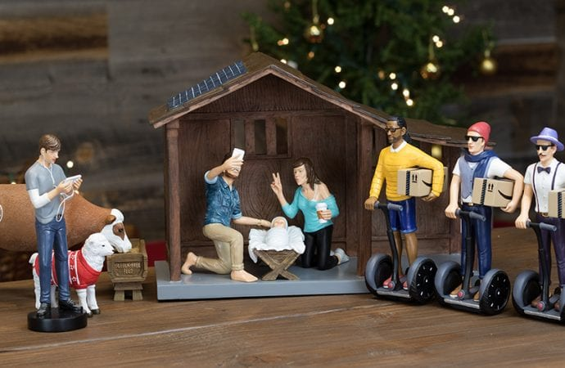
I liked the Hipster manger controversy even better. As soon as Irene saw it, she had to have it. Mary has a Starbucks in her hand. The Wise Men bring baby Jesus Amazon packages on Segways and Joseph is taking a selfie with his iPhone.

Casey Wright, who created this product, told CNBC about how people react. “It’s usually, ‘This is hilarious. I need one.’ Or ‘This is sacrilegious, I hope you burn in hell,’ and almost nothing between those two extremes.”

How do you feel about the commercialization of Christmas? We could fight it. We could aspire to a muscular Christianity.

But I am not interested in a Christianity forever offering its theological biceps to be felt, thumping its “holier than thou” breast, thanking heaven that it will, ultimately, with an inquisition or two, finally enforce religious uniformity and make North America great again.

Similarly, I am not interested in a Herod-type Christianity that insists every wise person must worship at his alter, in obedience to Fundamentalist pressure politics. I am not interested in a Gilead-type Christianity, as described in Margaret Atwood’s Handmaid’s Tale and The Testaments, where what you sing, and how you dress and what you are allowed to think is decided by politicians pretending to be religious.

I’ll be blunt here. Religious power corrupts, and absolute religious power that coerces people either by law or social pressure corrupts absolutely. Too much power for religion looks like residential schools training First Nations kids to pass for white. Too much power for religion looks like social mores that force LGBTQ people or atheists into their closets. And absolute power for religion looks like crusades and pogroms and prison for unbelievers and nonconformists.

No. I will not defend any attempt to officially put Jesus back into Christmas. There is a reason, according to our stories, that Jesus was born in a barn and laid in a manger. There is a reason he had, according to Isaiah, no form or majesty that we should desire him. There is a reason Jesus chose to be despised and rejected, a man of sorrows, who suffered and died rather than submit to the power of the priests or Romans. There is a reason Jesus fled to Egypt when Herod roared, instead of calling F-18s with angel pilots to blast him away.

You see, the very character of Christianity is that our persuasiveness never lies in power as Goliath or Herod or a prime minister might conceive of it—the power of a lobby or union or corporation to coerce.

No, we Christians choose to sing our Advent songs, and our lives, in a minor key. We choose to be a voice crying in the wilderness. The Christian way, when it comes to the war on Christmas, is to do as Jesus did, to turn the other cheek, clothe the naked, feed the hungry, provide good-paying jobs in vineyards, and create community where our care and concern turns heads.

It is true. Christianity is no longer the religion of the mostest. Our faith is being marched out of the public square. That’s okay. We don’t need to be an official religion to change the world. We need only strive to be like Christ, wherever and whenever we can—to bring Christ’s values to our families, our workplaces and corporations and our politics and hobbies. With kindness, seeking justice for the least and last when we can.

So never mind about the war on Christmas. It isn’t our war. And sure, go on, enjoy a month’s worth of Frosty the Snowman and Rudolph the Red-nosed camel—if you can stand it. Shop. Open gifts on Christmas morning. Enter into the general frivolity and generosity of the most secular season at its best. Have fun.

But do it with attitude of Christ. That’s all.

